APPENDIX

The Appendix was developed from the Los Angeles Hospital Mass Fatalities Incident Planning Checklist published August 2008

Table of Contents

Section 1: Overview
Assumptions 1
County-Wide Coordination 2
Key Contacts 3

section 2: Hospital Mass Fatality Incident (MFI) planning
Planning Overview 4
10 Questions to Get Started 5
Sample Table of Contents 6

Section 3: Hospital Mass Fatality Incident (MFI) response
Hospital Mass Fatality Incident (MFI) Management Unit 7
Job Action Sheet: Mass Fatality Incident Unit Leader 8
Checklist: Mass Fatality Incident Management Unit Equipment and Supplies 11
Card: Decedent Information and Tracking 12
Form: Fatality Tracking 13

section 4: Death Flow Process
Decedent Processing: Potential Bottlenecks 14
Flow Chart: Death at A Hospital 15
Flow Chart: Pandemic Influenza Death at A Hospital 16

section 5: Death certificates
Fact Sheet: About Death Certificates and Facts About Signing the Death Certificate 17
Sample: Form VS-11E Certificate of Death 18
Fact Sheet: California Electronic Death Registration System (CA-EDRS) 19
Fact Sheet: Information on the LAC Public Administrator 20

section 6: Decedent Handling and Storage
Fact Sheet: Health Risk from Dead Bodies and Basic Infection Control for Staff Handling Dead Bodies 21
Fact Sheet: Human Remains Storage Myths and Truths 22
Fact Sheet: Decomposition 25
Cultural Preferences…………………………………………………………………………………………….…..26
Fact Sheet: Recommended Methods of Storage for Hospitals 27
Checklist: Surge Morgue Equipment and Supplies 28

section 7: Additional Resources
Mass Fatality Pandemic Influenza Exercise Sample Pre and Post Test Questions 29
Definitions…………………………………………………………………………………………………………….31
Web Resources 32

assumptions

  - It is the duty of the Coroner/Medical Examiner to determine the circumstances, manner and cause of all violent, sudden, or unusual deaths.
  - A mass or multi fatality incident (MFI) results in a surge of deaths above which is normally managed by a community’s usual medicolegal system.
  - The Coroner/Medical Examiner is the lead agency to manage a mass fatality incident; however it is not solely responsible for all aspects of response to a mass fatality incident.
  - Medicolegal systems may continue to experience a “normal” case load as well as the case load from the Mass Fatality Incident with the possibility of an increase in accidental deaths (due to therapeutic complications and/or those resulting from the increased use and operation of motor vehicles/heavy equipment), homicidal (due to civil unrest), and/or suicide cases.
  - The Coroner/Medical Examiner, Department of Health Services, Department of Public Health, hospitals and other healthcare entities have limited fatality surge space or equipment.
  - Federal or military assistance in fatality management may not be available to local jurisdictions in widespread incidents such as a pandemic.
  - Disposition of human remains requires a death certificate.
  - In all US jurisdictions, a treating or primary care physician is authorized to sign a death certificate provided the patient dies from natural causes and has knowledge of the causes of death.
  - Human remains do not pose additional health risks to the community.
  - Those who physically handle remains may be at risk of blood borne or body fluid exposure requiring standard precautions and proper training for handling the dead.
  - It is more important to ensure accurate and complete death investigations and identification of the dead than it is to quickly end the response.
  - The time to complete fatality management of a mass fatality event may exceed six months to a year.
  - Mental health professionals, social service organizations and religious leaders will have to be educated in the mass fatality management process at all levels to ensure the process is understood and can be properly communicated to the general population in their response activities.

county or region-wide coordination

Mass fatalities may occur as the result of a variety of events, including natural disasters or disease outbreaks, large accidental incidents, or as the result of the intentional use of a chemical, biological, radiological, or explosive agent. Since a Mass Fatality Incident is likely to result from a major incident, law enforcement, such as the Sheriff’s Department, has overall responsibility for managing the incident response, and the local Emergency Management Agency has overall responsibility for managing recovery. (In a Mass Fatality Incident resulting from a pandemic, Public Health will most likely be the lead agency).

The Coroner/Medical Examiner is the lead agency on fatality management during a disaster, and should have an established Emergency Response Plan. Their Mass Fatality Plan should outline the actions to be taken by the Coroner/Medical Examiner and its relationships (via the Standardized Emergency Management System and Incident Command System) with the Operational Area, local, state and federal law enforcement, fire, hazmat, and Department of Public Health, on such topics as equipment, scene assessment, decedent transport, examining and processing, and body storage options. (Note: Federal or military assistance in fatality management may not be available to local jurisdictions in widespread incidents such as a pandemic.)

Each disaster scenario presents specific considerations, however all sudden and unexpected deaths as well as traumatic deaths fall under Coroner/Medical Examiner jurisdiction. A community-wide Mass Fatality Incident, especially one due to a disease outbreak or other public health emergency may also fall under the jurisdiction of the Public Health Officer. Hospitals should stay alert for supplemental guidance on identifying the underlying cause of death or other significant conditions contributing to death. This information may be issued from the Coroner/Medical Examiner or the Department of Public Health.

Hospitals should continue to interact and receive incident updates with the county/region via established systems.

key contacts should include

Coroner/Medical Examiner
- 24 hour phone contact
- Name, email, phone number

Local Emergency Medical Services Agency
- Phone number
- 24 hour phone contact
- Email, Web address

County Department of Public Health
- Phone number
- 24 hour phone contact
- Reporting name, email, phone contact

County/Region Morgue / Decedent Affairs
- Phone number

California Electronic Death Registration System (EDRS) Helpdesk
  - 916-552-8123
  - https://ca.edrs.us (CA-EDRS login page)

Hospital Mass Fataility Incident Planning overview

Joint Commission
While conducting hospital Mass Fatality Incident planning is prudent and should be a part of all emergency management plans and emergency operations plans, it is also an element in the Joint Commission Environment of Care Emergency Management in the Emergency Management Chapter and included in Standard EM.02.02.11 which states that as part of its Emergency Operations Plans, the organization prepares for how it will manage patients during emergencies. Specifically in EM.02.02.11.7, the performance measure states that the Emergency Operations Plan describes the following: How the hospital will manage mortuary services.

Hospital Preparedness Program
According to US Department of Health and Human Services Hospital Preparedness Program guidance (Target Measure H4.1), all HPP-funded hospitals will have a finalized written plan for mass fatality management. A finalized written plan is one that has received senior management approval. This plan should include at minimum, current on information on (a) trained and available personnel; (b) equipment, supplies, facilities, and other material resources; and (c) operational structure and standard operating procedures for disposition of the deceased.

Review Existing Hospital Resources and Plans/Policies/Practices
As part of the planning process, facilities should identify existing resources and procedures in place for the management of deaths. This may include Decedent Affairs or Medical Records departments. Staff may already be familiar with and regularly use common forms such as Coroner/Medical Examiner Hospital and Nursing Home Facility reporting forms, and Certificate of Death. They may already be trained on using the Electronic Death Registration System (EDRS). It is important to identify any formal or informal mass fatality or fatality surge plans that the facility may have. These may include memoranda of understanding (MOUs) with local mortuaries or refrigeration container companies. Many facilities have informal plans on managing a surge of fatalities, and these should be converted to written plans.

Develop a Written Plan
The included Hospital Multi-Fatality Plan checklist (see page 9) can be used to evaluate a current Mass Fatality Incident plan or provide guidance in developing a Mass Fatality Plan. And as always, be sure to train to and exercise the plan. The fact sheets and flow charts included in this guidance may be helpful when developing the plan and in conducting trainings.
Hospital Mass fatality incident Planning: 10 questions to get started

“Death does not end human suffering, especially when death is sudden, as the result of a disaster. The death of a loved one leaves an indelible mark on the survivors, and unfortunately, because of the lack of information, the families of the deceased suffer additional harm because of the inadequate way that the bodies of the dead are handled. These secondary injuries are unacceptable, particularly if they are the consequence of direct authorization or action on the part of the authorities or those responsible for humanitarian assistance.” Mirta Roses Periago, Director, Pan American Health Organization

- What are the decedent management priorities of your organization? What key assumptions are these priorities based upon?
- Does your organization have a written mass fatality plan in place? If so, who has the authority to activate these plans and/or procedures, and have you trained to the plan?
- Do you have staff and resources identified that will be dedicated to mass fatality incident management?
- What are the possible bottlenecks in the decedent processing procedures? Have any solutions been developed and/or implemented to mitigate these issues?
- What is the capacity of your morgue? Do you have alternate on-site and off-site surge morgue capacity? Do you have memoranda of understanding in place (if applicable)?
- Do you have staff and resources identified that will be dedicated to surge morgue management?
- To what extent can technology assist with decedent processing?
- Who in your organization or jurisdiction has the authority to make the decision to alter or change the current decedent processing and identification plan?
- What legal hurdles, if any, does your organization or jurisdiction face when executing your mass fatality incident plan? How will your organization and jurisdiction deal with them to ensure that the processing of decedents is not delayed or otherwise stalled by legal matters?
- What reputation management issues could arise if your facility does not adequately manage a mass fatality incident?

Hospital Mass fatality incident Planning: sample table of contents

- Purpose, Scope, and Assumptions
- Plan Activation Triggers and Procedures
- Mass Fatality Incident Management
  - Mass Fatality Incident Management Unit
    - Staffing Needs and Assignments
    - Location
    - Equipment and Supplies
  - Procedures for Decedent Identification and Tracking
  - Procedures for Death Certificate Completion and Electronic Death Registration System
  - Procedures for Custody of Personal Property and Evidence
  - Forms
  - Relationship with external/community partners
- Human Remains Management
  - Staffing Needs and Assignments
  - Normal morgue capacity
  - On-site surge morgue capacity
    - Location, including assessments
    - Capacity and manner of storage
    - Triggers for activation and demobilization
  - Off-site surge morgue capacity
    - Location, including assessments
    - Capacity and manner of storage
    - Triggers for activation and demobilization
    - Memoranda of Understanding, Agreement, or Contracts
  - Procedures for Human Remains Storage
  - Equipment and Supplies
  - Infection Control Policy
  - Security
- Psychosocial Considerations
- Plan Evaluation
  - Revision Process
  - Training and Exercise Program
- Related Emergency Management Program Documents
- References and Resources

hospital Mass Fatality Incident (MFI) Management unit

The purpose of a Hospital Mass Fatality Incident Management Unit is to have a centralized location where all mass fatality information is being processed in your facility in response to a mass-casualty event, pandemic outbreak, terrorist attack, or large natural disaster. Functions include:
- Decedent identification (if not already done upon admittance)
- Family/next of kin notification
- Coroner, County morgue or mortuary notification/contact
- Tracking decedents who die in the hospital to disposition out of the hospital
- Managing morgue capacity
- Managing surge morgue capacity

It is suggested that the Mass Fatality Incident Unit be located in the Hospital Incident Command System (HICS) Operations Section Medical Care Branch, and that the Mass Fatality Incident Unit Leader reports directly to the Medical Care Branch Director. The Mass Fatality Incident Unit will coordinate information with the Patient Registration Unit and the Casualty Care Unit, particularly for those patients identified as expectant. The Mass Fatality Incident Unit will also coordinate information with the Planning Section Situation Unit Patient Tracking Manager. During a disaster, it may not be possible to staff all positions; however they are identified here to help illuminate the roles and responsibilities that should be addressed.

In addition to a Mass Fatality Incident Unit Leader (see page 14 for a sample Job Action Sheet), recommended essential disciplines are identified in the table. Due to the sensitive nature of decedent processing, ensure all staff receive psychological support if needed. Be cautious in the use of hospital volunteers who may not have had experience or exposure to mass fatality situations.

Administrative Task Force | Morgue Task Force
- Decedent identification staff  - Decedent tracking staff  - Liaison to HICS Patient Tracking Officer and other Hospital Command Center contacts  - Data entry staff to Regional emergency communication system such as ReddiNet, and the Electronic Death Registration System  - Liaison to Public Health and other relevant County agencies, and mortuaries  - Liaison to families  - Death Certificate coordinator (a physician with responsibility to coordinate with other physicians to ensure death certificates are signed to expedite decedent processing)  - IT support | - Morgue supervisor  - 1-2 morgue assistants  (Minimum of two morgue task force members to safely move decedents)  - Infection control staff, as needed  - Morgue staff to maintain each morgue area  - Facilities/engineering to maintain the integrity of surge morgue areas  - Security for all morgues
Mass fatality incident unit Leader
job action sheet

Mission: Collect, protect, identify and track decedents.

Date: Start: End: Position Assigned to: Initial:
Position Reports to: Medical Care Branch Director Signature:
Hospital Command Center (HCC) Location: Telephone:
Fax: Other Contact Info: Radio Title:

Immediate (Operational Period 0-2 Hours) |  | Time |  | Initial
Receive appointment and briefing from the Medical Care Branch Director. Obtain Mass Fatality Incident Unit activation packet.
Read this entire Job Action Sheet and review incident management team chart (HICS Form 207). Put on position identification.
Notify your usual supervisor of your HICS assignment.
Determine need for and appropriately appoint Mass Fatality Incident Unit staff, distribute corresponding Job Action Sheets and position identification. Complete a unit assignment list.
Document all key activities, actions, and decisions in an Operational Log (HICS Form 214) on a continual basis.
Brief Mass Fatality Incident Unit staff on current situation; outline unit action plan and designate time for next briefing.
Confirm the designated Mass Fatality Incident Unit area is available, and begin distribution of personnel and equipment resources. Coordinate with the Medical Care Branch Director.
Regularly report Mass Fatality Incident Unit status to Casualty Care Unit Leader.
Assess problems and needs; coordinate resource management.
Use your Death Certificated Coordinator physician or request an on-call physician from the Casualty Care Unit Leader to confirm any resuscitatable casualties in Morgue Area.
Obtain assistance from the Medical Devices Unit Leader for transporting decedents. Assure all transporting devices are removed from under decedents and returned to the Triage Area.
Instruct all Mass Fatality Incident Unit Task Force members to periodically evaluate equipment, supply, and staff needs and report status to you; collaborate with Logistics Section Supply Unit Leader to address those needs; report status to Medical Care Branch Director.
Coordinate contact with external agencies with the Liaison Officer, if necessary.
Monitor decedent identification process.
Enter decedent information in regional emergency communication system such as ReddiNet, if appropriate.
Assess need for establishing surge morgue facilities.
Coordinate with the Patient Registration Unit Leader and Family Information Center (Operations Section) and the Patient Tracking Manager (Planning Section).
Contact the Medical Care Branch Director and Security Branch Director for any morgue security needs.
Document all communications (internal and external) on an Incident Message Form (HICS Form 213). Provide a copy of the Incident Message Form to the Documentation Unit.

Intermediate (Operational Period 2-12 Hours) | Time | Initial
Maintain master list of decedents with time of arrival for Patient Tracking Manager.
Assure all personal belongings are kept with decedents and/or are secured.
Assure all decedents in Mass Fatality Incident Areas are covered, tagged and identified where possible.
Monitor death certificate process.
Meet regularly with the Casualty Care Unit Leader for update on the number of deceased; status reports, and relay important information to Morgue Unit staff.
Implement surge morgue facilities as needed.
Continue coordinating activities in the Morgue Unit.
Ensure prioritization of problems when multiple issues are presented.
Coordinate use of external resources; coordinate with Liaison Officer if appropriate.
Contact the Medical Care Branch Director and Security Branch Director for any morgue security needs.
Develop and submit a Mass Fatality Incident Unit action plan to the Medical Care Branch Director when requested.
Ensure documentation is completed correctly and collected.
Advise the Medical Care Branch Director immediately of any operational issue you are not able to correct or resolve.
Ensure staff health and safety issues being addressed; resolve with the Safety Officer.

Extended (Operational Period Beyond 12 Hours) | Time | Initial
Continue to monitor the Mass Fatality Unit’s ability to meet workload demands, staff health and safety, resource needs, and documentation practices.
Coordinate assignment and orientation of external personnel sent to assist.
Work with the Medical Care Branch Director and Liaison Officer, as appropriate on the assignment of external resources.
Rotate staff on a regular basis.
Document actions and decisions on a continual basis.
Continue to provide the Medical Care Branch Director with periodic situation updates.
Ensure your physical readiness through proper nutrition, water intake, rest, and stress management techniques.
Observe all staff and volunteers for signs of stress and inappropriate behavior. Report concerns to the Employee Health & Well-Being Unit Leader. Provide for staff rest periods and relief.
Upon shift change, brief your replacement on the status of all ongoing operations, issues, and other relevant incident information.

Demobilization/System Recovery | Time | Initial
As needs for the Mass Fatality Unit decrease, return staff to their normal jobs and combine or deactivate positions in a phased manner, in coordination with the Demobilization Unit Leader.
Ensure the return/retrieval of equipment/supplies/personnel.
Debrief staff on lessons learned and procedural/equipment changes needed.
Upon deactivation of your position, brief the Medical Care Branch Director on current problems, outstanding issues, and follow-up requirements.
Upon deactivation of your position, ensure all documentation and Mass Fatality Incident Unit Operational Logs (HICS Form 214) are submitted to the Medical Care Branch Director.
Submit comments to the Medical Care Branch Director for discussion and possible inclusion in the after-action report; topics include:
- Review of pertinent position descriptions and operational checklists
- Recommendations for procedure changes
- Section accomplishments and issues
Participate in stress management and after-action debriefings. Participate in other briefings and meetings as required.

Documents/Tools
- Incident Action Plan
- HICS Form 207 – Incident Management Team Chart
- HICS Form 213 – Incident Message Form
- HICS Form 214 – Operational Log
- Mass Fatality Incident Activation/Operational Plan
- Mass Fatality Incident/Morgue Unit Assignment List
- Fatality Tracking Form
- Decedent Information and Tracking Card
- Hospital emergency operations plan
- Hospital organization chart
- Hospital telephone directory
- Key contacts list (including Coroner, Public Health, ReddiNet, Los Angeles County Department Mental Health, American Red Cross, etc.)
- Radio/satellite phone
Mass fatality incident management UNIT Equipment and supplies Checklist
Equipment and supplies for the Mass Fatality Incident Unit may include the following. Be sure to identify where items are stored and how to access the storage area.

Consideration | Consideration
Distance from the morgue  - Location of Mass Fatality Incident Unit:  - Distance from Morgue:  Notes:  Secure with limited access  - # of security staff required:  - Security equipment required:  - Description of how access is limited:  Notes:  Phone lines  - Incoming phone  - Outgoing phone  - Fax machine  - Fax paper and toner  - Total number of phones:  Notes:  Regional emergency communications system, such as ReddiNet and Electronic Death Registration System access/terminal  - Laptop or desktop computer  - Access to internet  - Emergency Communication access established  - Electronic Death Registration System access established (via internet for authorized individuals)  - Total number of computers:  Notes: | Tables and chairs  - # tables procured (based on layout needs)  - # chairs procured (based on layout needs)  Notes:  Office supplies  - Notepads, loose paper, sticky notes, clipboards  - Plastic sleeves  - Pens, pencils, markers, highlighters  - Stapler, staple remover, tape, packing tape, white out, paper clips, pencil sharpener  - Extension cords, power strips, surge protectors, duct tape  Notes:  Printer and Copier  - Printer and cables, copier  - Paper  - Toner  Notes:  Forms and Documents  - Hospital Mass Fatality Incident Plan  - Decedent Information and Tracking Card  - Fatality Tracking Form  - Electronic Death Registration System "Medical Facilities Users' Guide" (download at www.edrs.us)  - Internal and external contact lists  Notes:
Legend:
- Check boxes to indicate completion
- These bullets require you to add your information

Insert hospital name or logo
Hospital Address
Telephone and Fax Numbers
 |  |  | First Letter of Decedent Last Name: _______
decedent information and Tracking card

Incident Name |  |  | Operational Period
medical record / Triage # | date |  | time |  |  |  | hospital location prior to morgue
First | middle |  | Last |  |  |  | Age |  | gender
identification verified by
□ drivers license □ state id □ passport □ Birth certificate □ other:______________________________

Identification #: ________________________________________________________________________________________
Address (street address, city, state, zip)

listed in reddinet  □ Yes □ No | record created in EDRS  □ Yes □ No |  |  |  | death certificate signed  □ Yes □ No
photo attached to this card  □ Yes □ No |  |  | Fingerprints attached to this card  □ Yes □ No
next of kin notified?  □ Yes □ No | Name |  | Relation |  |  |  | Contact Tel
status | location |  | date / Time IN |  |  |  | date / Time OUT
hospital morgue
hospital morgue
hospital morgue
hospital morgue
final disposition | date / Time |  | NAME OF RECIPIENT |  |  |  | SIGNATURE OF RECIPIENT
RELEASED TO:  □ coroner  □ county morgue  □ mortuary  □ other: ______________ | Date  TIME
list Personal belongings |  |  |  |  |  | storage location
Original on file in Mass Fatality unit
copy with decedent
copy to medical care branch director
Form Revised: May 2008

Fatality Tracking Form
Adapted from HICS Form 254.
Incident Name |  |  |  | Date / Time Prepared |  |  |  | Operational Period Date/Time
Medical record number or Triage number | Name | Sex | DOB/  Age | next of kin notified  Yes / No | Entered: yes / No |  | hospital morgue |  | final Disposition, Released to:
 |  |  |  |  | Regional communi-cation system | EDRs | in  Date/Time | out  Date/Time | Coroner, Mortuary, county morgue, or other (List) | Date/Time
Completed By hospital mfi unit |  |  | name
Purpose: Account for decedents in a mass fatality disaster Origination: Hospital Mass Fatality Unit Copies to: Patient Registration Unit Leader and Medical Care Branch Director

Decedent processing – potential bottlenecks

Our goal is to ensure efficient, timely and respectful decedent processing from death to final disposition.

Problem | Solutions
Decedent Identification  The lack of identification impedes the process of identifying next of kin. | - Verify identification with a photo identification  - To confirm identification or to assist in identification at a later date, upon hospital admittance or immediately upon death:  - Take a photo (before decomposition sets in)  - Get fingerprints  - Collect X-rays or dental records
Next of Kin (NOK)  The lack of identifying NOK or being able to contact NOK delays the process of identifying desires for final disposition (and out of the hospital), such as which mortuary to contact | - Identify Next of Kin and contact information while the patient is still alive (perhaps upon admittance)  - Contact local government point of contact for notification
Death Certificate  Reluctance by physicians to sign the death certificate can impede the process of a decedent being released for final disposition (and out of the hospital) | - Conduct education on what it means to sign the death certificate  - During a disaster, identify a single physician who will serve as the a death certificate coordinator (a physician with responsibility to coordinate with other physicians to ensure death certificates are signed to expedite decedent processing)
Decedent Tracking  Hospitals may need to store remains for a short term until next of kin can be identified/notified or final disposition has been identified. A system of knowing who and where the decedents are will be crucial to expedite community-wide decedent processing. | - Use a form similar to the Decedent Information and Tracking Card to consolidate information about each decedent (see page 18)  - Develop a form or process to track all decedents (such as the form on page 19) or electronic database  - Ensure staff know how to use emergency communication system such as ReddiNet, however the hospital will need to maintain its own records  - Develop an address or locator process to quickly identify where a decedent is being stored (such as Surge Morgue 1, Rack 3, Tier 2). This can also be monitored on the Decedent Tracking Card if the decedent needs to be moved from one morgue area to another within the facility.
Property/Evidence  Depending on the incident, the decedent’s property may be evidence of a crime. It will need to be collected and maintained for proper transfer to authorities. | - Identify decedent’s property and where it is located if not co-located with the decedent. The Decedent Tracking Card or similar form can be used to catalog this information.
flow chart: death at a Hospital

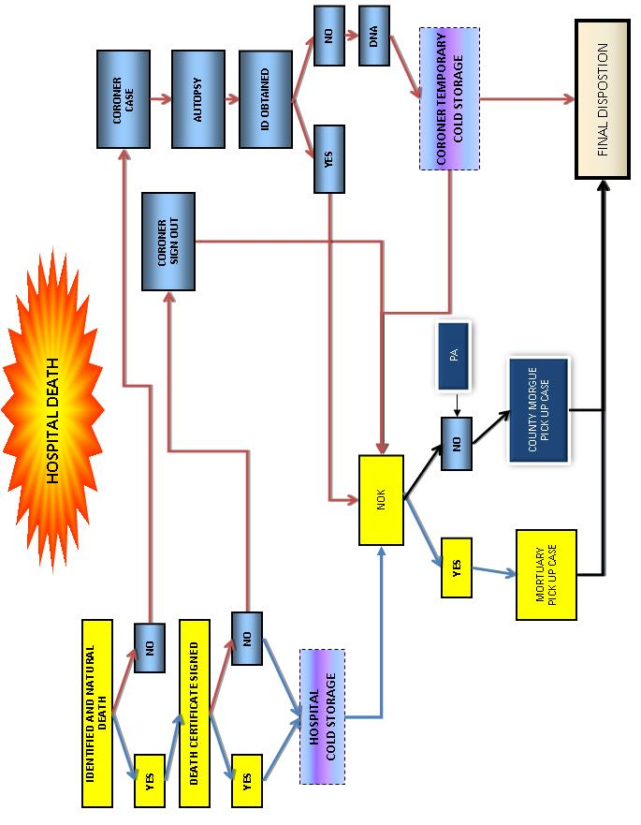
flow chart: Pandemic Influenza death at Hospital

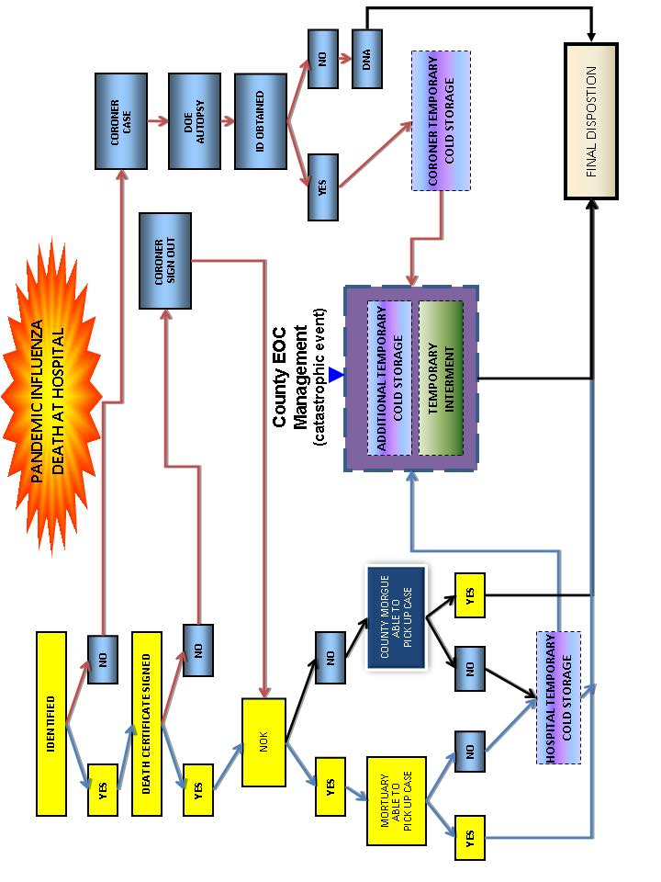
fact sheet

death certificates

About Death Certificates
- Permanent legal record of fact and cause of death
- Identifies deceased individual
- Includes demographic information of the deceased
- Specifies final disposition of the body
- Specifies the cause of death of the deceased
- Provides information about the funeral director and medical certifier completing the record
- Used for both administrative and public health analytical needs
- Necessary for the family to handle the business matters of the decedent
- If there is no family to take care the matters of the decedent, it becomes a public case and the disposition of the decedent is handled according to local guidance available from the Coroner/Medical Examiner.
- Source of mortality statistics at national and jurisdictional levels
- Data used to:
  - Allocate research and development funding
  - Establish goals related to public health
  - Measure health status
Facts about signing the death certificate
- Physicians must complete the medical portion of the death certificate within 15 hours of the death event
- The causes of death are the physician’s opinion regarding the death
- The physician is legally responsible to complete the medical portion of the death certificate
- The causes of death on the death certificate are not legally binding in and of themselves; the entire death certificate is the legal document
- The physician is not obligated to sign the death certificate if he/she determines that there was possible something unnatural about the cause of death – these should be referred to the Coroner
Websites
- Instructions for Completing the Cause-of-Death Section of the Death Certificate, CDC National Center for Health Statistics: http://www.cdc.gov/nchs/data/dvs/blue_form.pdf

sample death certificate from CA-EDRS: Form VS-11e

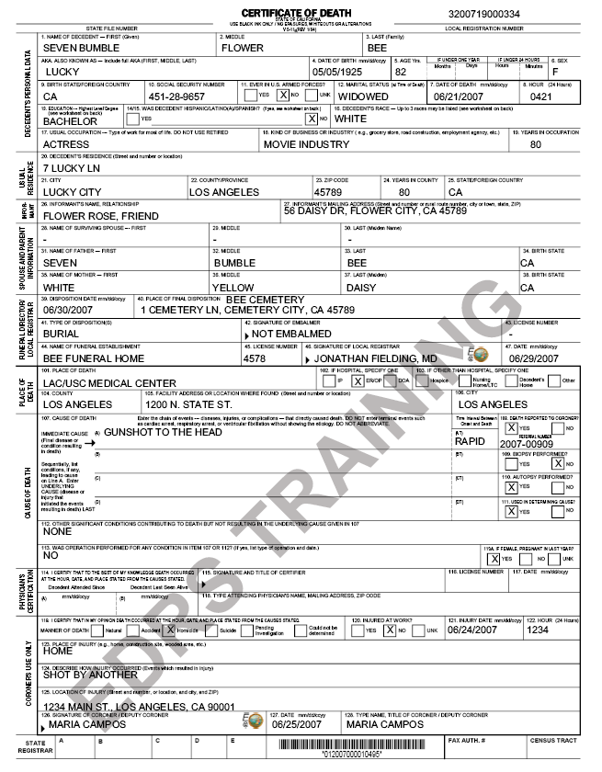
fact sheet

California electronic death registration system (ca-EDRS)

CA-EDRS Features
- Electronic filing of death certificates
- On-line collaboration among multiple death registration system users (funeral directors, medical facilities, local registrar, state registrar, etc.)
- User-friendly death record data entry screens
- Electronic signature (physicians, coroner staff, local registrar)
- Built-in instructions and on-line help
- Internet accessibility
- Electronic authentication (User IDs/passwords)
CA-EDRS Benefits
- Improved efficiency and timeliness in processing of the death certificate
- Document tracking – records are transferred electronically with unique record number
- Higher quality of data (internal data checks)
- Electronic signatures (coroner, physicians, funeral directors, medical facility staff, local registrar)
- Internet accessibility
- Disposition/burial permits printed at funeral homes, thereby expediting services for families
- Reduced number of amendments and duplicates due to error checks
Using Electronic Death Registration System During a Mass fatality Incident
- Death certificate processing does not change during a mass fatality incident
- Using the Electronic Death Registration System (EDRS) will expedite death certificate processing
- Hospitals that have staff trained to use the Electronic Death Registration System (EDRS) will be able to process death certificates more expediently
- NOTE: EDRS accounts require training – no accounts will be issued on an emergency basis
- Once the hospital has completed the decedent’s name, date of death, hour of death, causes of death, and has obtained the physician signature, the hospital can then forward the record to a mortuary or the Coroner
Websites
- https://ca.edrs.us (CA-EDRS login page)
- http://www.edrs.us (EDRS homepage/general information)

fact sheet

Information Specific to the LA County Public Administrator

This information is specific to the LA County Public Administrator but provides an example of how the process may work in your area. The Public Administrator for the County of Los Angeles has a staff of deputies to provide administration of the estates of decedents who were residents of Los Angeles County. The powers of the Public Administrator are mandated by the Probate Code of the State of California
The Public Administrator should be notified by anyone (mortuary, convalescent facility, hospital or private citizen) who has knowledge of an estate of a decedent under the following circumstances:
- Where there are no known heirs.
- When no executor or administrator has been appointed and the estate is being wasted, uncared for or lost.
- When the named executor of a Will fails to act and the court appoints the Public Administrator.
- When the Will names the Public Administrator as the estate administrator.
When an heir, or heirs, wish to have the Public Administrator administer the estate for them.
To report such an estate you may call the Investigation Unit of the Public Administrator's Office at 213-974-0460 or TTY: 213-628-4010. An investigator will be available to provide assistance in determining the need for the Public Administrator to administer the estate.

http://ttc.lacounty.gov/Proptax/PA_openning.htm

Fact Sheet
Health risk from Dead Bodies

Key Message
There is no risk of contagion or infectious disease from being near human remains
or for people who are not directly involved in recovery efforts.

Victims of natural disasters, accidents, or WMD events usually die from trauma and are unlikely to have acute or ‘epidemic-causing’ infections. In the event of an intentional release of a biological agent or natural pandemic resulting in mass casualties, the risk is greater from live victims rather than the dead. The microorganisms responsible for these diseases have limited ability to survive in a body that is cooling after death.

basic infection control for staff handling human remains
The safety of personnel performing these functions is paramount.
Measures should be taken to reduce the risk of infection associated with handling dead bodies.

- Standard precautions are essential for those handling dead bodies; avoid exposure to potential pathogens and via wounds/punctures or mucus membranes. Follow standard precautions for blood and body and enteric fluids.
- Other Personal Protective Equipment such as eyewear, gowns, and masks, may be required where large quantities or splashes of blood are anticipated.
- Appropriately dispose of used protective equipment such as gloves or other garments
- Avoid cross-contamination: personal items should not be handled while wearing soiled gloves. Hand washing is essential.
- In HazMat or WMD events, the appropriate level of Personal Protective Equipment is required depending on the agent.
- Vehicles used for transportation should be washed carefully with a disinfectant or decontaminated if appropriate
- Human remains pouches will further reduce the risk of infection and are useful for the transport of decedents that have been badly damaged. Wrapping with plastic and a sheet may be an economical and practical containment solution.
- There is NO risk of contagion from infectious diseases simply by being near or around human remains.
Fact Sheet

human remains storage myths and truths:
the good ideas

All delays between the death and autopsy hinder the medicolegal processes. All storage options should weigh the storage requirements against the time it takes to collect information that is necessary for identification, determination of the cause and circumstances of death, and next of kin notification.

Why Refrigeration Is Recommended
- Most hospital morgues’ refrigeration capacity will be exceeded during a disaster, especially if there are many unidentified bodies or remains recovered in the first hours of the event.
- Refrigeration between 38° and 42° Fahrenheit is the best option.
- Large refrigerated transport containers used by commercial shipping companies can be used to store up to 30 bodies. (Laying flat on the floor with walkway between).
  - Enough containers are seldom available at the disaster site.
  - Consider lightweight temporary racking systems. These can increase each container or room’s capacity by 3 times.
- Refrigeration does not halt decomposition, it only delays it.
  - Will preserve a body for 1-3 months.
  - Humidity also plays a role in decomposition. Refrigeration units should be maintained at low humidity.
  - Mold can become a problem on refrigerated bodies making visual identification impossible and interfering with medicolegal processes.
Why Dry Ice Is An Okay Recommendation
Dry ice (carbon dioxide (CO₂) frozen at –78.5° Celsius) may be suitable for short-term storage.
- Use by building a low wall of dry ice around groups of about 20 remains and then covering with a plastic sheet.
- About 22 lbs of dry ice per remains, per day is needed, depending on the outside temperature.
- Dry ice should not be placed on top of remains, even when wrapped, because it damages the body.
- Expensive, difficult to obtain during an emergency.
- Dry ice requires handling with gloves to avoid “cold burns.”
- When dry ice melts it produces carbon dioxide gas, which is toxic. The area needs good ventilation.
Human Remains Storage Myths and Truths Fact Sheet Page 1 of 3
Fact Sheet

human remains storage myths and Truths:
the bad ideas

Why Stacking Is Not Recommended
- Demonstrates a lack of respect for individuals.
- The placement of one body on top of another in cold or freezing temperatures can distort the faces of the victims, a condition which is difficult to reverse and impedes visual identification.
- Decedents are difficult to manage if stacked. Individual tags are difficult to read and decedents on the bottom cannot be easily removed.
Why Freezing Is Not Recommended
- Freezing causes tissues to dehydrate which changes their color; this can have a negative impact on the interpretation of injuries, as well as on attempts at visual recognition by family members.
- Rapid freezing of bodies can cause post-mortem injury, including cranial fracture.
- Handling bodies when they are frozen can also cause fracture, which will negatively influence the investigation and make the medicolegal interpretation of the examination results difficult.
- The process of freezing and thawing will accelerate decomposition of the remains.
Why Ice Rinks Are Not Recommended
- Ice rinks are frequently brought up as possible storage sites. As previously mentioned, freezing has several undesirable consequences.
- A body laid on ice is only partially frozen. It eventually will stick to the ice making movement of the decedent difficult.
- Management and movement of decedents on solid ground is challenging in good circumstances. Workers having to negotiate ice walkways would pose an unacceptable safely risk.
Why Packing In Ice Is Not Recommended
- Difficult to manage due to ice weight and transport issues.
- Large amounts are necessary to preserve a body even for a short time.
- Difficult to resource or obtain during an emergency.
- Ice is often a priority for emergency medical units.
- Results in large areas of run off water.
Human Remains Storage Myths and Truths Fact Sheet Page 2 of 3

Fact Sheet
human remains storage myths and truths:
Other Issues Not Directly Related to Hospital Storage

Packing with Chemicals
- Some substances may be used to pack a decedent for a short period. These chemicals have strong odors and can be irritating to workers.
- Powdered formaldehyde and powdered calcium hydroxide may be useful for preserving fragmented remains. After these substances are applied, the body or fragments are wrapped in several nylon or plastic bags and sealed completely.
Embalming
- The most common method.
- Not possible when the integrity of a corpse is compromised, i.e., it is decomposed or in fragments.
- Embalming requires a licensed professional with knowledge of anatomy and chemistry.
- Expensive, considerable time involved for each case.
- Used to preserve a body for more than 72 hours after death; transitory preservation is meant to maintain the body in an acceptable state for 24 to 72 hours after death.
- Embalming is required for the repatriation or transfer of a corpse out of a country.
Temporary Interment - Not a mass grave
- Temporary burial provides a good option for immediate storage where no other method is available, or where longer-term temporary storage is needed.
- While not a true form of preservation this is an option that might be considered when there will be a great delay in final disposition.
- Temperature underground is lower than at the surface, thereby providing natural refrigeration.
- Temporary burial sites should be constructed in the following way to help ensure future location and recover of bodies.
- Trench burial for larger numbers.
- Burial should be 5 feet deep and at least 600 feet from drinking water sources.
- Leave 1 foot between bodies.
- Lay bodies in one layer only. Do not stack.
- Clearly mark each body and mark their positions at ground level.
- Each body must be labeled with a metal or plastic identification tag.
Human Remains Storage Myths and Truths Fact Sheet Page 3 of 3

fact sheet

decomposition fact sheet

Definition
Decomposition is the disintegration of body tissues after death, and begins at the moment of death.

Causes of Decomposition
These processes release gases that are the chief source of the characteristic odor of dead bodies as well as cause the body to swell:
- Autolysis: self dissolution by body enzymes released from disintegrating cells
- Putrefaction: action of bacteria and other microorganisms
- Anthropophagy: insects and animals
Factors That Affect Decomposition
- Temperature
- Humidity or dryness
- The surface where the body lies
- Burial
- Wrapping
- Insect and scavenger activity
- Indoors vs. outdoors
- Water
- Fire
- Condition of the person prior to death

fact sheet

Cultural preferences

Cultural and Religious Considerations

The chart below provides summary information related to cultural and religious preferences regarding care of the deceased. Attempts should be made to care for the deceased consistent with these preferences. However, public health considerations and guidelines provided by regulatory bodies will also be considered. In the event there is conflict between public health considerations and cultural or religious preferences, public health considerations will take precedence.

Religion/Culture | Preference | Other Comments
Afghanistan | Rapid Burial
Amish | Burial
Arab Cultures | Rapid Burial
Buddhist | Burial
Chinese | Cremation | Burial
Christian Scientist | Burial | Cremation
Cuban | Burial
Eastern Orthodox | Burial
Filipino | Burial
Guatemalan | Burial
Hispanic/Latino (other) | Burial (Generally)
Indian | Cremation
Japanese | Burial
Jewish | Rapid Burial
Korean | Burial
LDS | Burial
Mexican | Burial
Native American | Burial
Pakistani | Rapid Burial | NO COFFIN
Polynesian | Burial
Puerto Rican | Burial
Rastafarian | Don’t believe in burial | ASK for Preference
Sri Lanka | Cremation
Vietnamese | Burial

recommended methods of storage for hospitals

All storage options should weigh the storage requirements against the time it takes to collect information that is necessary for identification, determination of the cause and circumstances of death, next of kin notification, and length of time the decedent will need to be stored until release to the Coroner, Morgue, or private mortuary.

Protecting the Decedent
- Decedents and their personal effects must be secured and safeguarded at all times until the arrival of the coroner’s or mortuary’s authorized representative, or law enforcement (if evidentiary).
- Placed in a human remains pouch or wrap in plastic and a sheet.
- If personal effects have been removed from the body, ensure the items have been catalogued (such as on the Decedent Information and Tracking Card on page 18) and are secure.
- Be sure the decedent is tagged with identification information.
Refrigeration is the Recommended Method of Storage
- Refrigeration between 38° and 42° Fahrenheit is the best option.
- Refrigeration units should be maintained at low humidity.
- Existing hospital morgue: most hospital morgues’ refrigeration capacity will be exceeded during a disaster, especially if there are many unidentified bodies or remains recovered
- Surge Morgues
  - Rooms, tents or large refrigerated transport containers used by commercial shipping companies that have the temperature controlled may also serve as surge morgues
  - May be cooled via the HVAC system, portable air conditioners, or the correct application of dry ice (see Fact Sheet: Human Remains Storage Myths and Truths: Why Dry Ice Is An Okay Recommendation on page 29)
  - Containers may be used to store up to 30 bodies by laying remains flat on the floor with walkway between
Beds, Cots, or Racking Systems – Not Stacking
- See Fact Sheet: Human Remains Storage Myths and Truths: Why Stacking is Not Recommended on page 30
- The floor can be used for storing remains, however it may be safer and easier to identify and move remains on beds, cots or racking systems
- Consider lightweight temporary racking systems. These can increase each room or container’s capacity by 3 times, as well as create a specific storage location for tracking. These may be specifically designed racks for decedents, or converted storage racks (such as large foodservice shelving, 72” wide by 24” deep; ensure that these are secured and can handle the weight load).
surge morgue Equipment and Supplies Checklist

Equipment and supplies for the surge morgue areas may include the following. Be sure to identify where items are stored and how to access the storage area.

Consideration | Your Facility Notes / How to Access Equipment
Staff Protection  - Personal protective equipment (minimum standard precautions)  - Worker safety and comfort supplies  - Communication (radio, phone) | - Storage area:  - How to access:  - Notes:
Decedent Identification  - Identification wristbands or other identification  - Method to identify each decedent (pouch label, tag or rack location)  - Cameras (may use dedicated digital, disposable, or instant photo cameras)  - Fingerprints  - X-rays or dental records  - Personal belongings bags / evidence bags | - Storage area:  - How to access:  - Notes:
Decedent Protection  - Human remains pouches  - Plastic sheeting  - Sheets | - Storage area:  - How to access:  - Notes:
Decedent Storage  - Refrigerated tents or identified overflow morgue area  - Storage racks  - Portable air conditioning units  - Generators for lights or air conditioning  - Ropes, caution tape, other barricade equipment | - Storage area:  - How to access:  - Notes:

Mass Fatality Pandemic Influenza Exercise
Sample Pre and Post Test Questions

 | Question | True or False
 | There is no risk of contagion or infectious disease from being near human remains for people who are not directly involved in handling the bodies.  True: Unless you are directly handling decedents, there is no risk (including no records of epidemics or outbreaks) from being near dead bodies—and for those handling decedent, basic standard precautions are recommended. | True
 | You can contract influenza (flu) from passive exposure (being near) decedents who have died from flu.  False: You cannot contract influenza from passive exposure (being near) to dead bodies—dead bodies don’t cough. And for those handling decedents, basic standard precautions are all that is necessary. | False
 | During the winter, “influenza” is the most commonly noted cause of death listed on death certificates.  False: Because diagnostic/confirmatory influenza tests are rarely conducted, and because of the natural progression of disease (from illness to potential subsequent death), while influenza may have been the preceding cause of death, it is rarely listed on death certificates. Instead, pneumonia and other secondary illness (cardiac arrest, etc.) are the predominant listed cause of death. | False
 | Counting the number of people who have “influenza” listed as the cause of death on their death certificate is not an accurate indicator of the number of people who have actually died from flu.  True: Because of the lag time and natural progression form initial infection to death, flu is rarely identified as the cause of death on death certificates. Instead “pneumonia” is used as a surrogate measure to attempt to better estimate the number of deaths that may have been caused by flu. | True
 | The Coroner is required to investigate the cause of death for every case.  False: The code requires the Coroner “to determine the circumstances, manner and cause of all violent, sudden, or unusual deaths: including unattended deaths wherein the deceased has not been seen by a doctor in the 20 days prior to death.” | False
 | The last flu pandemic resulted in fewer U.S. deaths than what is typically expected from seasonal flu.  True: The last influenza pandemic (the “Hong Kong Flu” of 1968) resulted in 34,000 US deaths; less than what is expected of a typical US influenza season (36,000 death expected annually). | True
 | By definition, influenza pandemics are more severe (have significantly higher resulting fatality rates) as compared to seasonal strains of influenza.  False: A pandemic simply means “worldwide illness.” A pandemic may not necessarily result in more deaths than what we experience every season from seasonal flu, and the last pandemic (the Hong Kong flu of 1986) actually resulted in fewer U.S. deaths (34,000) than what we expect every year from seasonal flu (approximately 36,000 annually). | False
 | The attending physician must complete the medical portion of the death certificate within 72 hours of the death.  False: The attending physician is required to complete this medical portion within 15 hours of the death. | False
 | A physician signing the death certificate is legally responsible for the cause(s) of death listed on the death certificate.  False: The physician is legally responsible for completing the medical portion with the causes of death, but it is the entire death certificate that is the legal document, not the causes of death themselves. | False
 | Hospitals will be required to have a mass fatality management plan.  True: Joint Commission Standards: 2008: EC.4.18.5 which asks for a plan to describe how the hospital will manage mortuary services. The standard will be reassigned in 2009 to EM.02.02.11. It is also a requirement of the Hospital Preparedness Program. | True
 | The Public Administrator gets involved in Decedent Affairs when:  - No next-of-kin are found/come forward  - Next-of-kin reside outside the U.S., or decline to act for the Decedent  - Assets are “subject to loss, injury, waste, or misappropriation…” (Prob. C. §7601(a))  - The appointed administrator or executor fails to act (properly)  True: As mandated by the Probate Code of the State of California. | True
 | The Public Administrator will investigate any case referred by:  - A public officer (§7600)  - A hospital, nursing home, etc. (§7600.5)  - A mortuary (§7600.6)  - A court (§7620(c))  - Any person (§7620(b))  True: As mandated by the Probate Code of the State of California. | True
 | The Coroner is the only individual allowed to sign a death certificate.  False: Others with this ability/responsibility include the attending physician and emergency department physician. | False

definitions

Definitions from the Santa Clara County Mass Fatality Plan
Please note that some definitions are not verbatim from related codes and regulations but are paraphrased for clear understanding of the concepts involved.

- Coordinator of Coroner Functions in the Operational Area: The Medical Examiner/Coroner’s Administration will coordinate all medical examiner and coroner functions within the operational area.
- Death Care Industry: The death care industry involves the management of all funerary arrangements including care of the dead and services offered to surviving family members. This includes services offered by funeral homes, cemeteries and crematories. California Department of Consumer Affairs, Cemetery and Funeral Bureau is the state regulatory agency.
- Disaster Mortuary Operational Response Team (DMORT): DMORTs are teams comprised of private citizens each with a particular field of expertise, who are activated in the event of a disaster. Members are required to maintain appropriate certifications and licenses within their discipline. When members are activated, licensure and certification is recognized by all states and the team members are compensated for their duty time by the Federal government as a temporary Federal employee. During an emergency response, DMORTs function under the guidance of local authorities by providing technical assistance and personnel to recover, identify, and process deceased victims. DMORTs are comprised of funeral directors, medical examiners, coroners, pathologists, forensic anthropologists, medical records technicians and transcribers, finger print specialists, forensic odontologists, dental assistants, x-ray technicians, mental health specialists, computer professionals, administrative support staff, and security and investigative personnel. For further information see website: www.dmort.org.
- Family Assistance Center (FAC): The traditional family assistance center is a secure facility established as a centralized location to provide information about missing persons who may be victims of a disaster; a gathering point where information is exchanged in order to facilitate the body identification process and the reunification of next of kin; a location for the collection of DNA; and where spiritual and emotional support is provided for those awaiting information about their loved ones. Also, given the circumstances, additional support services such as housing, information/referral, insurance, financial assistance, and legal assistance may be provided.
- Mass Fatality: Any situation in which there are more human remains to be processed and managed than can be handled by the usual resources of the Medical Examiner/Coroner.
- Personal Protective Equipment (PPE): PPE is specialized clothing and equipment worn by fatality management personnel for protection against health and safety hazards. Personal protective equipment is designed to reduce exposure and protect vulnerable parts of the body.
- Region: The State of California is divided into seven Coroner Mutual Aid Regions.
- Repatriation: Repatriation is the process of returning the deceased to their country of birth, nationality or permanent residence.
- Standardized Emergency Management System (SEMS): The Standardized Emergency Management Systems (SEMS) is a system used for coordinating State and local emergency response in California. SEMS provides a multiple level emergency response organization that facilitates the flow of emergency information and resources.
- Unified Command: Unified Command is comprised of representatives of jurisdictions that have an implicit/direct responsibility for the incident. The objective and strategy of Unified Command should be to reach consensus in the consolidated action plan for the incident. In this manner, the effectiveness of the response to a multi-jurisdictional or multi-agency incident is increased.

California
- California Electronic Death Registration System
  - https://ca.edrs.us (CA-EDRS login page)
  - http://www.edrs.us (EDRS homepage/general information)
- California Health & Safety Code 103451, Definition of a Mass Fatalities Incident: http://www.leginfo.ca.gov/cgi-bin/displaycode?section=hsc&group=103001-104000&file=103450-103490
- Standards and Guidelines For Healthcare Surge During Emergencies: http://bepreparedcalifornia.ca.gov/epo/cdphprograms/publichealthprograms/emergencypreparednessoffice/epoprogramsservices/surge/
- Los Angeles Hospital Mass Fatality Incident Planning Checklist: http://ems.dhs.lacounty.gov/ManualsProtocols/MFIM/MFIGuidanceForHospitals808.pdf
Federal
- CDC: Instructions for Completing the Cause-of-Death Section of the Death Certificate, CDC National Center for Health Statistics: http://www.cdc.gov/nchs/data/dvs/blue_form.pdf
- CDC: Interim Health Recommendations for Workers Who Handle Human Remains: http://www.bt.cdc.gov/disasters/tsunamis/handleremains.asp
- CDC: Disposing of Liquid Waste from Autopsies in Tsunami-Affected Areas: http://www.bt.cdc.gov/disasters/tsunamis/pdf/tsunami-autopsyliquidwaste.pdf
- CDC: Standard Precautions Guidelines: www.cdc.gov/ncidod/dhqp/gl_isolation_standard.html
- DHHS: Radiation Event Medical Management: Management of the Deceased: http://www.remm.nlm.gov/deceased.htm
- OSHA: Health and Safety Recommendations for Workers Who Handle Human Remains: http://www.osha.gov/OshDoc/data_Hurricane_Facts/mortuary.pdf
- CHPPM: Guidelines for Protecting Mortuary Affairs Personnel from Potentially Infectious Materials, October 2001: http://chppm-www.apgea.army.mil/documents/TG/TECHGUID/TG195a.pdf
Pan American Health Organization (PAHO)
- Management of Dead Bodies After Disasters: A Field Manual for First Responders: http://www.paho.org/english/dd/ped/DeadBodiesFieldManual.htm
- Management of Dead Bodies in Disaster Situations: http://www.paho.org/english/dd/ped/ManejoCadaveres.htm
- Mass Fatality Plan Checklist for Ministries of Health and National Disaster Offices: http://www.paho.org/english/dd/ped/deadbodies5checklist.htm
- Eberwine, Donna. Disaster Myths That Just Won't Die. http://www.paho.org/english/dd/pin/Number21_article01.htm
- Morgan O, Ville de Goyet Cd. Dispelling disaster myths about dead bodies and disease: the role of scientific evidence and the media. http://journal.paho.org/index.php?a_ID=121
Other Resources
  - International Mass Fatalities Center: http://www.massfatalities.com/
  - National Mass Fatalities Institute: http://www.nmfi.org/
  - Online Mass Fatalities Course, University of Minnesota Center for Public Health Preparedness: http://cpheo.sph.umn.edu/umncphp/online/home.html
  - Online Resource Center Cross Cultural Mourning Practices: http://www.hmtri.org/library/mass_fatalities.htm#mourning

