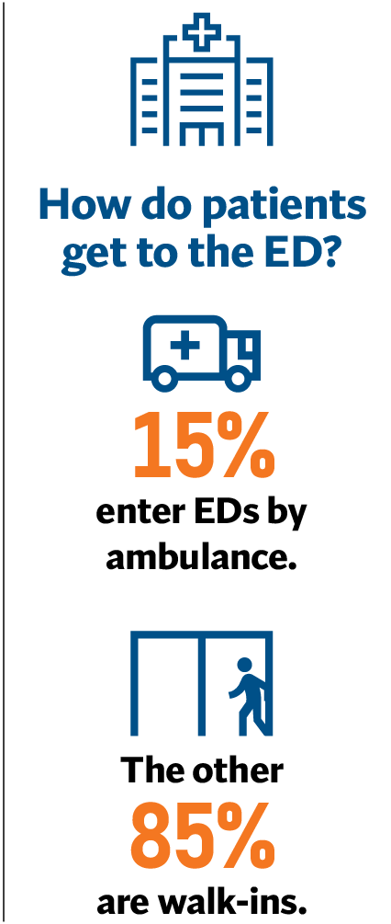
Tailored Approach Needed to Reduce Ambulance Offload Delays
The Issue
Every hospital in the state uses a clinically driven process to evaluate, triage, and deliver appropriate care to anyone who seeks help. This includes making sure those with the greatest needs are treated first, as well as treating all patients as quickly as possible.
Still, improvements can be made, including reducing the time it takes to treat patients arriving via ambulance. To do this, it is critical for all involved — hospitals, fire departments, ambulance providers, local emergency medical services agencies (LEMSAs), skilled-nursing facilities, and more — to examine and address the systemic issues that contribute to delays in ambulance patient offload times (APOT).
It’s important to note that, while data on offload delays are captured at hospitals, most factors contributing to delays are not the result of hospitals’ actions or policies. APOT is a complex issue, exacerbated by the pandemic, resulting from systemic challenges across the entire health care delivery system.
That’s why it’s critical that any legislation to reduce offload times foster tailored approaches to account for geographic disparities, localized health system capacity, and more. These strategies should be informed by an accurate and uniform approach to data collection and analysis and goals that are meaningful, achievable, and sustainable.
The arbitrary, statewide APOT standard proposed in Assembly Bill (AB) 40 threatens patient safety and would further strain the ability to deliver care to all in need, especially given that only 15% of patients arrive at an ED by ambulance. Of those patients who arrive by ambulance, 77% are lower acuity and do NOT need emergency care. Multiple challenges must be addressed, including increased ED use for non-emergency conditions, lack of primary care resulting in sicker patients when they arrive at the ED, increased use of EDs for patients in a behavioral health crisis, fewer community care discharge options, workforce shortages, and more. Hospitals recognize the need to reduce offload times and are working closely with all involved to find solutions.
What’s Needed
A significant gap in data collection and analysis must be bridged to address delays in APOT. One-size-fits-all legislation will only address a single outcome resulting from a much larger system capacity problem. A statewide, arbitrary standard as proposed in AB 40 does nothing to solve the behavioral health crisis or lack of appropriate discharge options. Hospitals are eager to be a part of the solution and support many of the current proposals in AB 40 that would address delays such as public education on 911 use, an update of the toolkit to reduce APOT, and the development of a joint LEMSA hospital surge plan.

