**REASSURING OUR COMMUNITIES:**

**A CHA COMMUNICATIONS TOOLKIT**

**Caring for the sick and healing the injured — without regard to a patient’s ethnicity or citizenship status — is the mission of all hospitals. Day in and day out, year after year, the doctors, nurses and other health professionals who work in California hospitals provide necessary medical care to those in need.**

**There is a special trust between patients and health care providers. No one should ever be afraid to seek care for themselves or their loved ones because they fear being deported.**

The national debate surrounding federal immigration policies provides an important opportunity for California hospitals to reinforce the bond they have with local communities. Accordingly, CHA has developed the Reassuring Our Communities Communications Toolkit. It includes background information and sample content for use with internal and external audiences. These resources can be used by hospitals to communicate with patients, employees, community leaders, the news media and the public through a variety of communications channels. Given the heightened attention to how federal immigration officials carry out their duties, hospital leaders have an opportunity to reassure the public that hospitals are always ready to provide care to all patients regardless of their citizenship status. Hospitals do not ask patients about their immigration status, nor do they report undocumented individuals to authorities.

**COMMUNICATIONS TOOLKIT CONTENTS**

The Reassuring Our Communities Communications Toolkit includes background materials and sample content that hospitals can modify to fit their specific needs. The Toolkit contains the following items:

* ***Legal Fact Sheet***
* ***Frequently Asked Questions***
* ***Public Information Package***
  + Message/Talking Points (English and Spanish)
  + Sample Media Statement (English and Spanish)
  + Sample Opinion Editorial (English and Spanish)
  + Sample Letter to the Editor (English and Spanish)
  + Sample ICE Inquiry Response Scenario
* ***Sample Employee Newsletter Article***
* ***Sample Social Media Content*** 
  + Sample Facebook Posts & Graphics
  + Sample Tweets & Graphics
* ***Sample Hospital Policies and Collateral****Available as PDFs at* [*calhospital.org/reassuring-our-communities*](http://www.calhospital.org/reassuring-our-communities)
  + UCSF Benioff Children’s Hospital
  + Alameda Health System
  + Contra Costa Regional Medical Center & Health Center

**PATIENT PRIVACY RIGHTS IN RESPONDING TO INQUIRIES**

**FROM ICE OR OTHER LAW ENFORCEMENT OFFICIALS**

**FACT SHEET**

**Law Enforcement Protocol**

**The U.S. Department of Homeland Security Immigration and Customs Enforcement (ICE) is responsible for enforcing federal immigration laws.** An ICE officer is like any other law enforcement officer seeking a patient or information about a patient. Hospital clinical and front-line staff should treat ICE agents the same as they would treat any other law enforcement officer.

**Under state and federal health information privacy laws,[1] hospitals generally can release limited information about a patient’s condition to a member of the public or the news media if the inquiry specifically contains the patient’s name AND the patient has not requested that information be withheld.** However, privacy laws are less clear about the ability of hospitals to release general patient information when the inquiry is made by a law enforcement officer.

**Accordingly, hospital staff should neither confirm nor deny the presence of a patient to a law enforcement officer or federal immigration official without a signed court order or search warrant.[2]** It is important to note that a subpoena alone is not sufficient. A signed court order must accompany any subpoena in order for hospital staff to provide information about a patient.

**Hospitals should be aware that law enforcement officers have the ability to obtain court orders and search warrants very quickly.** The officer should be informed that the hospital will wait while an order is obtained. If an ICE agent presents a court order or search warrant, the hospital should follow its usual procedure for responding to court orders or search warrants presented by any other law enforcement officer.

**Law enforcement officers have, on occasion, been very persistent in attempting to obtain information from a hospital, even to the point of threatening hospital employees with charges of impeding an investigation or obstructing justice.** Hospital staff should be equally persistent in declining to respond to requests for information without appropriate legal authorization.

A hospital should have a standard response ready, such as “*you will need to talk to the administrator on duty*” or “*you will need to talk to the CEO’s office tomorrow morning*,” that front-line staff can continue to repeat to any overly-persistent officer.

**Hospital Directory**

**Most hospitals maintain a hospital directory, which lists the name and room number of inpatients. The directory is used by hospital operators and lobby desk staff.** It is legal for a hospital to disclose the name and room number of patients to callers and visitors, such as family members, friends, clergy, florists, etc.

**Patients are informed at the time of admission of the existence of the hospital directory and how to opt out of being listed.** However, many patients do not read the **Notice of Privacy Practices** right away. A hospital may choose to bring this information to their patients’ attention by using a separate document or by having admitting personnel notify them verbally.

**Patients should be aware that if a plain-clothed or undercover law enforcement officer appears at the hospital and does not identify himself/herself, the hospital may treat the officer like any other visitor.** This means that, unless the patient has opted out of the directory listing, the hospital may confirm the presence of a patient and tell the visitor/officer the patient’s room number.

**CHA’s *California Health Information Privacy Manual* contains detailed information on the Notice of Privacy Practices, the patient’s right to opt out of the hospital directory, and a sample form for patients to complete if they wish to opt out.** For more information about the manual or to order a copy, visit www.calhospital.org/privacy.

**REASSURING OUR COMMUNITIES**

**FREQUENTLY ASKED QUESTIONS**

**Q: Community health care groups suggest there is growing level of wariness and fearfulness from people who might need medical care but fear deportation. What are hospitals doing specifically in terms of outreach to reassure people, especially in minority communities?**

**A:** Caring for the sick and healing the injured, without regard to a patient’s ethnicity or citizenship status, is the mission of all hospitals. Nothing about that has changed. This longstanding policy is specifically designed to protect the overall health and well-being of the community. Hospital professionals communicate with patients from diverse ethnic and socio-economic backgrounds every day, and staff is trained to accommodate everyone.

**Q: Do you think the intent of the new immigration crackdown is to discourage people from seeking medical attention? Why or why not?**

**A:** We won’t speculate about that, but we can assure you that it is our duty to make sure patients and their families feel safe and welcome at a hospital. Hospital employees do not ask patients about their immigration status or report undocumented individuals.

Trained hospital professionals know how to work with law enforcement to protect patient privacy. Patients seeking hospital care can request that their presence and all other information remain confidential. If this request is made, hospital staff will not confirm or deny the presence of any individual without a signed court order or search warrant. It is important to note that a subpoena alone is not sufficient. A signed court order by a judge must accompany any subpoena in order for hospital staff to provide information about a patient.

It also is important to note that the mandate to safeguard patient privacy when it involves sharing information with law enforcement officials falls under a different set of laws (via the Penal Code) than it does when the inquiry comes from non-law enforcement sources.

**Q: What are the public health implications if those from immigrant groups simply start avoiding institutions like hospitals or clinics?**

**A:** It is critical that any person in need of immediate medical attention gets it promptly. Otherwise, their health and the health of the community could be jeopardized.

When you or a family member is sick, the last thing on your mind should be whether you will be

safe in the hospital. Our message to the community is important: No one should ever be afraid

of seeking care for themselves or their loved ones because they fear being deported.

**Q: Shouldn’t these groups be afraid? Can federal immigration officials or other law enforcement personnel gain background information on patients without a warrant?**

**A:** No. Federal law affords people privacy protections that hospital professionals strictly follow. While the U.S. Department of Homeland Security Immigration and Customs Enforcement (ICE) is responsible for enforcing federal immigration laws, hospitals do not collect information on any patient’s immigration status, nor do they report undocumented patients to federal immigration authorities.

Patients seeking hospital care can request that their presence and all other information remain confidential. If this request is made, hospital staff will not confirm or deny the presence of any individual without a signed court order or search warrant. It is important to note that a subpoena alone is not sufficient. A signed court order by a judge must accompany any subpoena in order for hospital staff to provide information about a patient.

It also is important to note that the mandate to safeguard patient privacy when it involves sharing information with law enforcement officials falls under a different set of laws (via the Penal Code) than it does when the inquiry comes from non-law enforcement sources.

**Q: What are hospitals doing to protect patients from law enforcement inquiries or actions? Aren’t there limits to that screening or protection?**

**A:** Law enforcement officers have, on occasion, been very persistent in attempting to obtain information from a hospital, even to the point of suggesting that hospital employees are impeding an investigation or obstructing justice. In these instances, hospital staff must be equally persistent in declining to respond to requests for information without appropriate legal

authorization.

For example, hospital staff should have a standard response ready, such as “*you will need to talk to the administrator on duty*” or “*you will need to talk to the CEO’s office*,” that front-line staff can continue to repeat to any overly-persistent officer.

If a federal immigration official or other law enforcement officer presents a signed court order or search warrant, the hospital should follow its usual procedure for responding to these legal orders.

**Patients are informed at the time of admission of the existence of the hospital directory and how to opt out of being listed.** However, many patients do not read the **Notice of Privacy Practices** right away. A hospital may choose to bring this information to their patients’ attention by using a separate document or by having admitting personnel notify them verbally.

**Patients should be aware that if a plain-clothed or undercover law enforcement officer appears at the hospital and doesn’t identify himself/herself, the hospital may treat the officer like any other visitor. This means that, unless the patient has opted out of the directory listing, the hospital may confirm the presence of a patient and tell the visitor/officer the patient’s room number.**

**REASSURING OUR COMMUNITIES**

**KEY MESSAGES/TALKING POINTS**

* ***Hospitals have always provided care to everyone in need, regardless of a person’s ability to pay, the language they speak or their immigration status. No one should ever be afraid to seek care because they fear deportation.***
  + The mission of all California hospitals is to provide necessary medical care to anyone in need, regardless of a person’s ability to pay or immigration status.
  + Hospitals are open and welcome everyone 24 hours a day, seven days a week. Nobody is ever turned away.
  + This is longstanding policy that protects the health and well-being of our communities.
* ***Hospitals do not ask patients about their immigration status or report undocumented individuals to federal immigration officials.***
  + Hospitals follow strict federal and state laws to protect each patient’s right to privacy, and hospital personnel are trained to work with federal and state law enforcement officials.
  + Patients seeking hospital care can request that their presence and all other information remain confidential. If this request is made, hospital staff will not confirm or deny the presence of any individual without a signed court order or search warrant.
  + It is important to note that a subpoena alone is not sufficient. A signed court order by a judge must accompany any subpoena in order for hospital staff to provide information about a patient.
  + **Patients are informed at the time of admission of the existence of the hospital directory and how to opt out of being listed.** However, many patients do not read the **Notice of Privacy Practices** right away. A hospital may choose to bring

this information to their patients’ attention by using a separate document or by having admitting personnel notify them verbally.

* + **Patients should be aware that if a plain-clothed or undercover law enforcement officer appears at the hospital and doesn’t identify himself/**

**herself, the hospital may treat the officer like any other visitor. This means that, unless the patient has opted out of the directory listing, the hospital may confirm the presence of a patient and tell the visitor/officer the patient’s room number.**

* + It also is important to note that the mandate to safeguard patient privacy when it involves sharing information with law enforcement officials falls under a different set of laws (via the Penal Code) than it does when the inquiry comes from non-law enforcement sources.
* ***People should never be afraid to seek care for themselves or loved ones at a hospital.***
  + There is a special trust between patients and health care providers. Hospitals are a place where men, women and children can get the care they need.
  + People who need medical attention should seek it immediately. Otherwise, they jeopardize their health and the health of others.

**BRINDAR SEGURIDAD A NUESTRAS COMUNIDADES**

**MENSAJES CLAVE/TEMAS DE DEBATE**

* ***Los hospitales siempre han brindado atención a todos quienes la necesitan, independientemente de la capacidad de una persona para pagar, el idioma que hable o su situación migratoria. Nadie debería jamás tener miedo de buscar atención por temor a ser deportado.***
  + La misión de todos los hospitales de California es proporcionar la atención médica necesaria a cualquiera que la necesite, independientemente de la capacidad de una persona para pagar o de su estado migratorio.
  + Los hospitales están abiertos y reciben a todo el mundo las 24 horas del día, los siete días de la semana. Nunca rechazamos a nadie.
  + Esta es la política de larga data que protege la salud y el bienestar de nuestras comunidades.
* ***Los hospitales no preguntan a los pacientes acerca de su situación migratoria ni denuncian a las personas indocumentadas ante los funcionarios federales de inmigración.***
  + Los hospitales respetan estrictas leyes federales y estatales para proteger el derecho de cada paciente a la privacidad, y se capacita al personal del hospital para trabajar con las autoridades federales y estatales encargadas de hacer cumplir la ley.
  + Los pacientes que buscan atención hospitalaria pueden solicitar que su presencia y todo el resto de la información sean confidenciales. Si se hace esta petición, el personal del hospital no confirmará ni negará la presencia de ninguna persona sin una orden judicial firmada o una orden de registro.
  + Es importante tener en cuenta que una citación judicial sola no es suficiente. Una orden judicial firmada por un juez debe acompañar cualquier requerimiento para que el personal del hospital suministre información acerca del paciente.
  + **Se informa a los pacientes en el momento del ingreso de la existencia del directorio del hospital y cómo elegir no ser incluidos en el mismo.** Sin embargo, muchos pacientes no leen el **Aviso de Prácticas de Privacidad** inmediatamente. Un hospital puede optar por dar esta información a sus pacientes mediante un documento separado o mediante personal de admisión que les informe verbalmente.
  + **Los pacientes deben saber que si un oficial de policía vestido de civil o encubierto se presenta en el hospital y no se identifica, el hospital puede tratar al oficial de policía como a cualquier otro visitante. Esto significa que, a menos que el paciente haya optado por no ser incluido en el directorio, el hospital podrá confirmar la presencia de un paciente y suministrarle al visitante/oficial de policía el número de habitación del paciente.**
  + También es importante tener en cuenta que la obligación de salvaguardar la privacidad del paciente cuando ello implica compartir información con los oficiales de policía está enmarcada en un conjunto de leyes diferentes (a través del Código Penal) a las que rigen la solicitud que proviene de fuentes no policiales.
* ***Las personas nunca deberían tener miedo de buscar atención médica para ellos mismos o para sus seres queridos en un hospital.***
  + Existe una confianza especial entre pacientes y proveedores de atención médica. Los hospitales son lugares donde los hombres, las mujeres y los niños pueden recibir la atención que necesitan.
  + Las personas que necesitan atención médica deberían buscarla inmediatamente. De lo contrario, pueden poner en peligro su salud y la salud de otros.

**REASSURING OUR COMMUNITIES**

**SAMPLE MEDIA STATEMENT**

“Caring for the sick and healing the injured, without regard to a patient’s ethnicity or citizenship status, is the mission of all hospitals. This longstanding policy is specifically designed to protect the overall health and well-being of the community.

Nobody should ever be afraid to seek care for themselves or their loved ones because they fear being deported. Hospital employees do not ask patients about their immigration status or report undocumented individuals.

Patients seeking hospital care can request that their presence and all other information remain confidential. If that request is made, hospital staff will not confirm or deny the presence of any individual without a signed court order or search warrant. It is important to note that a subpoena alone is not sufficient. A signed court order by a judge must accompany any subpoena in order for hospital staff to provide information about a patient.

There is a special trust between patients and health care providers, and people needing medical attention should always seek it immediately. Maintaining that bond is a hospital’s sole focus so people receive the care they need.”

**NAME**

**TITLE**

**HOSPITAL NAME**

# # #

**BRINDAMOS SEGURIDAD A NUESTRAS COMUNIDADES**

**EJEMPLO DE UNA DECLARACIÓN DE PRENSA**

“Cuidar a los enfermos y curar a los heridos, independientemente del origen étnico o condición de ciudadanía de un paciente, es la misión de todos los hospitales. Esta antigua política está específicamente diseñada para proteger la salud en general y el bienestar de la comunidad.

Nunca nadie debería tener miedo de buscar atención médica para ellos mismos o sus seres queridos por temor a ser deportados. Los empleados de los hospitales no preguntan a los pacientes acerca de su situación migratoria ni denuncian a las personas indocumentadas.

Los pacientes que buscan atención hospitalaria pueden solicitar que su presencia y todo el resto de la información sean confidenciales. Si se hace tal solicitud, el personal del hospital no va a confirmar o negar la presencia de ninguna persona sin una orden judicial o una orden de registro firmadas. Es importante tener en cuenta que una citación judicial sola no es suficiente. Una orden judicial firmada por un juez debe acompañar cualquier requerimiento para que el personal del hospital suministre información acerca del paciente.

Existe una confianza especial entre pacientes y proveedores de atención médica, y quienes necesitan atención médica deberían buscarla inmediatamente. Mantener ese vínculo es el único objetivo del hospital para que todos reciban la atención médica que necesitan”.

**NOMBRE**

**PUESTO**

**NOMBRE DEL HOSPITAL**

# # #

**REASSURING OUR COMMUNITIES**

**SAMPLE OP-ED**

**Hospitals Care For Everyone Without Regard to Immigration Status**

**By XXXXXX**

The national debate surrounding federal immigration policy provides an important opportunity for California hospitals to reinforce the bond they have with local communities. We want to reassure the public that **HOSPITAL NAME** will always be accessible to everyone regardless of their citizenship status. This policy and commitment to being accessible to everyone has been in place for decades, because it is important that any person in need of medical treatment gets it promptly. Otherwise, their health and the health of the community could be jeopardized.

It is important for people to know how hospital professionals interact with law enforcement officials.

Our team works closely with public safety officers to ensure hospitals are safe, but our doctors, nurses and other professionals do not ask patients about their immigration status or report undocumented people. The U.S. Department of Homeland Security Immigration and Customs Enforcement (ICE) is responsible for enforcing federal immigration laws, but ICE officers are treated just like any other law enforcement officials. We respect our public safety partners because they go to extraordinary lengths to protect our community. It is our experience that officers respect our commitment to protecting patient privacy and following all laws protecting patient privacy.

When patients seek care at a hospital, they can request that their presence and all other information remain confidential. In the event that a federal immigration official enters a hospital seeking information about a patient who has made this request, trained hospital professionals will neither confirm nor deny the presence of any individual without a signed court order or search warrant. It is important to note that a subpoena alone is not sufficient. A signed court order by a judge must accompany any subpoena in order for hospital staff to provide information about a patient.

This longstanding policy protects the overall health and well-being of the community. These policies have been in place for decades, because caring for the sick and healing the injured,

without regard to a patient’s ethnicity or citizenship status, is the mission of all hospitals. Day in and day out, year after year, **HOSPITAL NAME** professionals provide care with compassion to those in need. When you or a family member is sick, the last thing on your mind should be if you will be safe in the hospital.

There is a special trust between patients and health care providers, and our message is simple. No one should ever be afraid to seek care for themselves or their loved ones because they fear being deported. It is no secret that the immigration issue has generated a lot of interest, but it is our responsibility to act and share information with people who may not be sure about what questions we ask, how we work with public safety officials and, most importantly, the steps hospitals take to protect patient privacy.

The bottom line is that caring for our community is the reason that **HOSPITAL NAME** exists.

**BRINDAR SEGURIDAD A NUESTRAS COMUNIDADES**

**EJEMPLO DE UN ARTÍCULO DE OPINIÓN**

**Los hospitales atienden a todos sin tener en cuenta su situación migratoria**

**Por XXXXXX**

El debate nacional que rodea la política federal de inmigración brinda una importante oportunidad para que los hospitales de California refuercen el vínculo que tienen con las comunidades locales. Queremos brindar seguridad al público afirmando que **NOMBRE DEL HOSPITAL** siempre estará disponible para todas las personas, independientemente de su situación de ciudadanía. Esta política y compromiso de ser accesibles a todos ha estado vigente desde hace décadas, ya que es de suma importancia que una persona que necesita tratamiento médico lo reciba de inmediato. De lo contrario, pueden poner en peligro su salud y la salud de la comunidad.

Es importante que todos sepan de qué manera los profesionales de los hospitales interactúan con los funcionarios policiales.

Nuestro equipo trabaja estrechamente con los funcionarios de seguridad pública para garantizar que los hospitales sean seguros, pero nuestros médicos, enfermeros y otros profesionales no preguntan a los pacientes acerca de su situación migratoria ni denuncian a las personas indocumentadas. La Oficina de Inmigración y Aduanas (ICE, por sus siglas en inglés) del Departamento de Seguridad Interna de EE. UU. es responsable de hacer cumplir las leyes federales de inmigración, pero los funcionarios de la ICE son tratados como cualquier otro funcionario policial. Respetamos a nuestros socios de seguridad pública porque toman medidas extraordinarias para proteger a nuestra comunidad. Según nuestra experiencia, los funcionarios respetan nuestro compromiso de proteger la privacidad de los pacientes y de cumplir todas las leyes que protegen su privacidad.

Cuando los pacientes buscan atención en un hospital, pueden solicitar que su presencia y todo el resto de la información sean confidenciales. En el caso de que un funcionario federal de inmigración ingrese a un hospital buscando información sobre un paciente que ha hecho esta solicitud, los profesionales del hospital, especialmente capacitados, ni confirmarán ni negarán la presencia de ningún individuo sin una orden judicial o una orden de registro. Es importante tener en cuenta que una citación judicial sola no es suficiente. Una orden judicial firmada por un juez debe acompañar cualquier requerimiento para que el personal del hospital suministre información acerca del paciente.

Esta política arraigada protege la salud en general y el bienestar de la comunidad. Estas políticas han estado vigentes durante décadas, porque la atención de los enfermos y la curación de los heridos, sin tener en cuenta la etnia o la situación de ciudadanía del paciente, es la misión de todos los hospitales. Día tras día, año tras año, los profesionales de **NOMBRE DEL HOSPITAL** brindan atención médica con compasión a las personas que la necesitan. Cuando usted o un familiar están enfermo, lo último que debe pensar usted es si estará seguro en el hospital.

Existe una confianza especial entre pacientes y proveedores de atención médica, y nuestro mensaje es simple. Nunca nadie debería tener miedo de buscar atención médica para sí o para sus seres queridos por temor a ser deportado. No es un secreto que el asunto de la inmigración ha generado mucho interés, pero es nuestra responsabilidad actuar y compartir información con personas que podrían no estar seguras acerca de las preguntas que hacemos, o sobre cómo trabajamos con los funcionarios de seguridad pública y, aún más importante, las medidas que toman los hospitales para proteger la privacidad del paciente.

La conclusión es que el cuidado de nuestra comunidad es la razón por la que **NOMBRE DEL HOSPITAL** existe.

**REASSURING OUR COMMUNITIES**

**SAMPLE LETTER TO THE EDITOR**

**Hospitals Care For Everyone Without Regard to Immigration Status**

**(200 words maximum)**

Dear Editor:

The national debate surrounding federal immigration policy provides an important opportunity for hospitals across our state to reinforce the bond they have with patients and families.

**HOSPITAL NAME** wants to reassure the **COMMUNITY NAME** that we are here, 24 hours a day, seven days a week to provide necessary medical care to anyone in need. No one should ever be afraid of seeking care because they fear deportation.

While we work closely with public safety officers to ensure our facilities are safe for everyone, our doctors, nurses and other professionals do not ask patients about their immigration status or report undocumented people. This longstanding policy protects the overall health and well-being of our community.

Caring for the sick and healing the injured, without regard to a patient’s ethnicity or citizenship status, is the mission of all hospitals. Day in and day out, year after year, **HOSPITAL NAME** professionals provide care with compassion to those in need.

There is a special trust between patients and health care providers, and our message is simple. We are here when you need us.

Sincerely,

**AUTHOR**

**BRINDAR SEGURIDAD A NUESTRAS COMUNIDADES**

**EJEMPLO DE CARTA AL EDITOR**

**Los hospitales atienden a todos sin tener en cuenta su situación migratoria**

**(200 palabras máximo)**

Estimado Editor:

El debate nacional que rodea la política federal de inmigración brinda una importante oportunidad para que los hospitales de California refuercen el vínculo que tienen con los pacientes y sus familias.

**NOMBRE DEL HOSPITAL** quiere garantizar a **NOMBRE DE LA COMUNIDAD**  que estamos aquí, 24 horas al día, siete días a la semana, para brindar la atención médica necesaria a todo aquel que la necesite. Nadie debe tener miedo de buscar ayuda por temor a ser deportado.

Mientras trabajamos estrechamente con los funcionarios de seguridad pública para garantizar que los hospitales sean seguros, nuestros médicos, enfermeras y otros profesionales no preguntan a los pacientes acerca de su situación migratoria ni denuncian a las personas indocumentadas. Esta antigua política protege la salud en general y el bienestar de la comunidad.

Cuidar a los enfermos y curar a los heridos, independientemente de su origen étnico o de la situación de ciudadanía de un paciente, es la misión de todos los hospitales. Día tras día, año tras año, los profesionales de **NOMBRE DEL HOSPITAL** brindan atención médica con compasión a aquellos que la necesitan.

Existe una confianza especial entre pacientes y proveedores de atención médica, y nuestro mensaje es simple. Estamos aquí cuando nos necesite.

Atentamente,

**AUTOR**

**REASSURING OUR COMMUNITIES**

**SAMPLE ICE INQUIRY RESPONSE SCENARIO**

The U.S. Department of Homeland Security Immigration and Customs Enforcement (ICE) is responsible for enforcing federal immigration laws.An ICE officer is like any other law enforcement officer seeking a patient or information about a patient. Hospital clinical and front-line staff should treat ICE agents the same as they would treat any other law enforcement officer.

**Hospital staff should neither confirm nor deny the presence of a patient to a law enforcement officer or federal immigration official without a signed court order or search warrant.[3]** It is important to note that a subpoena alone is not sufficient. A signed court order must accompany any subpoena in order for hospital staff to provide information about a patient.

**Law enforcement officers have, on occasion, been very persistent in attempting to obtain information from a hospital, even to the point of threatening hospital employees with charges of impeding an investigation or obstructing justice.** Hospital staff should be equally persistent in declining to respond to requests for information without appropriate legal authorization.

**A hospital should have a standard response ready, such as “*you will need to talk to the administrator on duty*” or “*you will need to talk to the CEO’s office tomorrow morning*,” that front-line staff can continue to repeat to any overly-persistent officer.**

It also is important to note that the mandate to safeguard patient privacy when it involves sharing information with law enforcement officials falls under a different set of laws (via the Penal Code) than it does when the inquiry comes from non-law enforcement sources.

**Patients are informed at the time of admission of the existence of the hospital directory and how to opt out of being listed.** However, many patients do not read the **Notice of Privacy Practices** right away. A hospital may choose to bring this information to their patients’ attention by using a separate document or by having admitting personnel notify them verbally.

**Patients should be aware that if a plain-clothed or undercover law enforcement officer appears at the hospital and doesn’t identify himself/herself, the hospital may treat the officer like any other visitor. This means that, unless the patient has opted out of the directory listing, the hospital may confirm the presence of a patient and tell the visitor/officer the patient’s room number.**

**The following scenarios reflect the way a hospital employee can effectively and lawfully address officer inquiries:**

**SCENARIO ONE – BASIC INQUIRY**

**Officer:** I’m looking for information about John Smith. What can you tell me?

**Hospital Representative (if the patient has opted-out of disclosure):** I appreciate your question, but we cannot confirm or deny that a person named John Smith is a patient here at the hospital unless you have a signed court order or search warrant. I would be happy to refer you to the administrator on duty if you have any questions.

**Hospital Representative (if the patient has not opted-out of disclosure):** I appreciate your question, but we cannot confirm or deny that a person named John Smith is a patient here at the hospital unless you have a signed court order or search warrant. I would be happy to refer you to the administrator on duty if you have any questions.

*(Repeat as necessary and contact the administrator on duty promptly.)*

**SCENARIO TWO – AGGRESSIVE INQUIRY**

Law enforcement officials have, on occasion, been very persistent in attempting to obtain information from a hospital, even to the point of threatening hospital employees with charges of impeding an investigation or obstructing justice. Hospital staff should be equally persistent in declining to respond to requests for information without appropriate legal authorization.

**Officer:** Stop obstructing and give me the information I need. This is an ongoing criminal investigation, and you’re in the way.

**Hospital Representative (If the patient has opted-out of disclosure):** I am sorry, but I cannot confirm or deny that John Smith is a patient here or provide any other information unless you have a signed court order or search warrant. I can put you in contact with the hospital CEO who can address your questions.

**Hospital Representative (If the patient has not opted-out of disclosure):** I am sorry, but I cannot confirm or deny that John Smith is a patient here or provide any other information unless you have a signed court order or search warrant. I can put you in contact with the hospital CEO who can address your questions.

*(Repeat as necessary and contact the administrator on duty promptly.)*

**REASSURING OUR COMMUNITIES**

**SAMPLE EMPLOYEE NEWSLETTER ARTICLE**

**Hospitals Care For Everyone Without Regard to Immigration Status**

The national debate surrounding federal immigration policy provides an important opportunity for California hospitals to reinforce the bond they have with local communities. We want to reassure the public that **HOSPITAL NAME** has always been accessible to everyone regardless of their citizenship status.

While our team of professionals works closely with public safety officers to ensure hospitals are safe, our doctors, nurses and other professionals do not ask patients about their immigration status or report undocumented people. This longstanding policy protects the overall health and well-being of the community.

As you know, under state and federal health information privacy laws, hospitals generally can release limited information about a patient’s condition to a member of the public or the news media if the inquiry specifically contains the patient’s name AND the patient has not requested that information be withheld. However, privacy laws are less clear about the ability of hospitals to release general patient information when a law enforcement officer makes the inquiry.

Accordingly, when patients have requested that their information remain private, hospital staff should neither confirm nor deny the presence of a patient to a federal immigration official unless a signed court order or search warrant is presented. It is important to note that a subpoena alone is not sufficient. A signed court order must accompany any subpoena in order for hospital staff to provide information to a federal immigration official about a patient. **INSERT DIRECTION SPECIFIC TO THE HOSPITAL REGARDING HOW EMPLOYEES SHOULD HANDLE INTERACTION WITH LAW ENFORCEMENT.**

Caring for the sick and healing the injured, without regard to a patient’s ethnicity or citizenship status, is the mission of all hospitals. Day in and day out, year after year, **HOSPITAL NAME** professionals provide care with compassion to those in need.

There is a special trust between patients and health care providers, and our message is simple. No one should ever be afraid to seek care for themselves or their loved ones because they fear being deported. We appreciate all that you do to deliver excellent care to our community.

**REASSURING OUR COMMUNITIES**

**SAMPLE FACEBOOK POSTS & GRAPHICS**

***(POST SAMPLE IMAGE WITH FOLLOWING CONTENT)***

Caring for the sick and healing the injured, without regard to a patient’s ethnicity or citizenship status, is the mission of all hospitals. This longstanding policy is specifically designed to protect the overall health and well-being of the community.

Nobody should ever be afraid to seek care for themselves or their loved ones because they fear being deported. Hospital employees do not ask patients about their immigration status or report undocumented individuals.

There is a special trust between patients and health care providers, and people needing medical attention should always seek it immediately. Maintaining that bond is a hospital’s sole focus, so people receive the care they need.





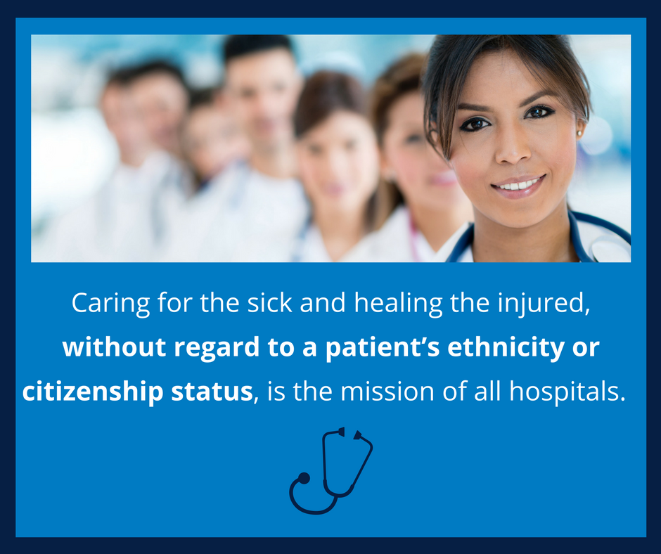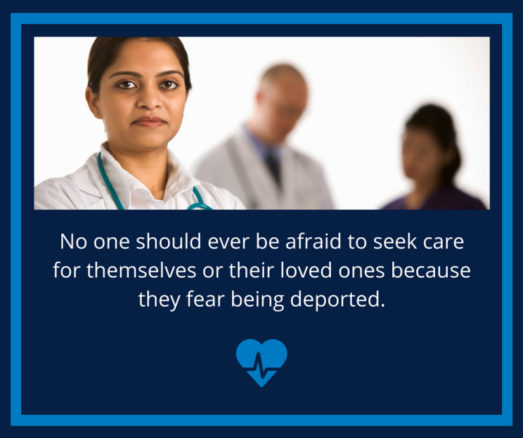

**REASSURING OUR COMMUNITIES**

**SAMPLE TWEETS & GRAPHICS**

***(POST SAMPLE IMAGE WITH FOLLOWING CONTENT)***

* Caring for the sick and healing the injured, without regard to a patient’s ethnicity or citizenship status, is the mission of all hospitals.
* Nobody should ever be afraid to seek care for themselves or their loved ones because they fear being deported. <<insert sharegraphic>>
* There is a special trust between patients and health care providers, and people needing medical attention should always seek it immediately.

# # #







1. The Confidentiality of Medical Information Act, Calif. Civil Code §56 et seq.; the Lanterman-Petris-Short Act, Calif. Welfare and Institutions Code §5328 et seq.; Calif. Penal Code §§1523-1545; the Health Insurance Portability and Accountability Act of 1996, 45 C.F.R. parts 160 and 164.
2. An exception to this general rule exists for hospitals and practitioners making required reports to law enforcement agencies, such as mandated reports of gunshot wounds and other suspicious injuries, child and elder abuse, etc. Such reports are made to local law enforcement agencies, not to ICE agents.
3. An exception to this general rule exists for hospitals and practitioners making required reports to law enforcement agencies, such as mandated reports of gunshot wounds and other suspicious injuries, child and elder abuse, etc. Such reports are made to local law enforcement agencies, not to ICE agents.