California Hospital COVID-19 Reporting Guidance

Table of Contents

Executive Summary 3
Reporting Overview: Why Data Reporting is Vitally Important 5
How to Successfully Complete Reporting: A Step-by-Step Guide 6
How and When to Report 6
Entering Data into the CHA COVID-19 Tracking Tool 7
Entering Data into the HHS TeleTracking Portal 11
Additional Guidance for General Reporting 12
Appendix
Data Dictionary – Additional Clarifications 14
CMS Enforcement Process for Non-Compliance 26
CDPH Calculations Prior to Uploading Data to TeleTracking 28
Other Resources 33

Executive Summary
California is committed to collecting accurate and complete hospital data, as this information is crucial to managing the COVID-19 public health emergency (PHE). These data are also of vital importance to the U.S. Department of Health and Human Services (HHS), which is using it to make resource allocation decisions at the federal level. To emphasize the importance of complete COVID-19 data reporting, on September 2, 2020, HHS announced that it would be implementing stricter enforcement of hospital reporting. Failure to comply with required reporting triggers a federal multi-step process of enforcement for non-compliance, which can result in the termination of the Medicare provider agreement. Termination of the Medicare provider agreement enacts the regulatory requirements at 42 CFR 455.416, which directs state Medicaid agencies to deny or terminate enrollment of any Medicaid or Children’s Health Insurance Program (CHIP) provider who is terminated from the Medicare program.
Recognizing the importance of this reporting and with the desire to make compliance as simple as possible for hospitals, California convened an interdisciplinary workgroup to provide feedback on the reporting process. Together, the workgroup developed this guidance document, which includes in-depth information on the data reporting process. In this document, you will be provided with information on why reporting COVID-19 data is important, how to successfully report data, clarification of specific data dictionary variables, and other additional information that may be needed for complete and accurate data reporting.
Ensuring that all hospitals report each variable uniformly is necessary to ensure the accuracy and integrity of the data. This document is meant to be used as a reporting companion guide to help ensure California’s hospitals remain in compliance with state and federal reporting requirements.

Reporting Overview: Why Data Reporting is Vitally Important
Data reporting is critical to the COVID-19 response to facilitate planning, monitoring, and resource allocation during the COVID-19 PHE. The data are used to inform decisions at the federal, state, and local levels. Allocations of supplies, treatments, and other resources are informed by the data reported by hospitals. This reporting is the only data available to state and federal governments for resource allocation purposes.
Failure to report complete data may lead to serious consequences. The Centers for Medicare & Medicaid Services (CMS) will issue two warnings and three enforcement letters before terminating a hospital’s Medicare provider agreement. Regulatory requirements at 42 CFR 455.416 direct state Medicaid agencies to deny or terminate enrollment of any Medicaid or CHIP provider who is terminated from the Medicare program.
Policy makers rely on the analysis of the data reporting to make critical management decisions during the COVID-19 pandemic. Our strategy for protecting the public health and welfare of all Californians relies upon ensuring accurate and high-quality reporting from California’s hospitals. We can’t achieve the shared goal of keeping Californians healthy without your continued efforts, and we greatly appreciate your hard work.

How to Successfully Complete Reporting: A Step-by-Step Guide

How and When to Report
Exactly how and for which days a hospital must report data to the state and federal government are dictated by two elements. The first is the hospital type. General acute care hospitals (GACHs), rehabilitation hospitals, and long-term care facilities must report their data to the CHA COVID-19 Tracking Tool by noon (PT). Psychiatric hospitals must report their data directly to HHS via the TeleTracking portal. While GACHs and long-term care facilities report data daily, rehabilitation and psychiatric hospitals report only on Wednesdays.
The second element that dictates how data will be reported is based on a hospital’s preference. A GACH, rehabilitation hospital, or long-term care facility can opt out of having the state submit data to HHS on its behalf by sending an e-mail to CDPH at COVID-19-CHCQData@cdph.ca.gov. After informing CDPH of its desire to opt out, the hospital must report to both the CHA COVID-19 Tracking Tool and the HHS TeleTracking portal (note, this is not applicable to psychiatric hospitals that must report their data directly to HHS).

Facility Type | Reporting To | Frequency
General Acute Care Hospitals (GACHs) | - CHA COVID-19 Tracking Tool – Required  - HHS TeleTracking Portal – Optional. GACHs must notify CDPH if they choose to opt out of having the state submit data on their behalf. | Daily
Psychiatric Hospitals | - HHS TeleTracking - Required | Weekly: Wednesdays
Rehabilitation Hospitals | - CHA COVID-19 Tracking Tool – Required  - HHS TeleTracking – Optional. Rehabilitation hospitals must notify CDPH if they choose to opt out of having the state submit data on their behalf. | Weekly: Wednesdays
Long-Term Care Facilities | - CHA COVID-19 Tracking Tool – Required  - HHS TeleTracking – Optional. Long-term care facilities must notify CDPH if they choose to opt out of having the state submit data on their behalf. | Daily

Entering Data into the CHA COVID-19 Tracking Tool
There are two options for uploading data into the CHA COVID-19 Tracking Tool (detailed steps given below). For the current day, a hospital can enter its data manually or it can upload a spreadsheet with one or multiple hospitals’ data for that day. It is important to note that both options require the user to first set up a SmartSheet account using their work e-mail address and a password of their choice. Once the account is verified by SmartSheet, the user can access the CHA COVID-19 Tracking Tool Overview Dashboard using a Chrome browser to request access to the tool.

Instructions for Uploading Manual Entry for Single Hospital
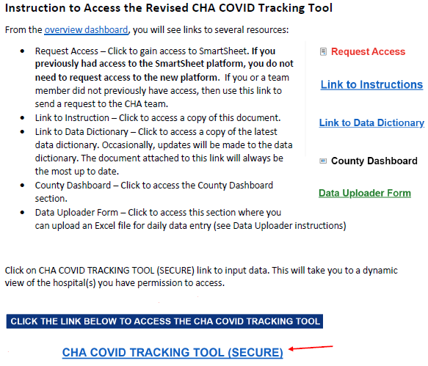
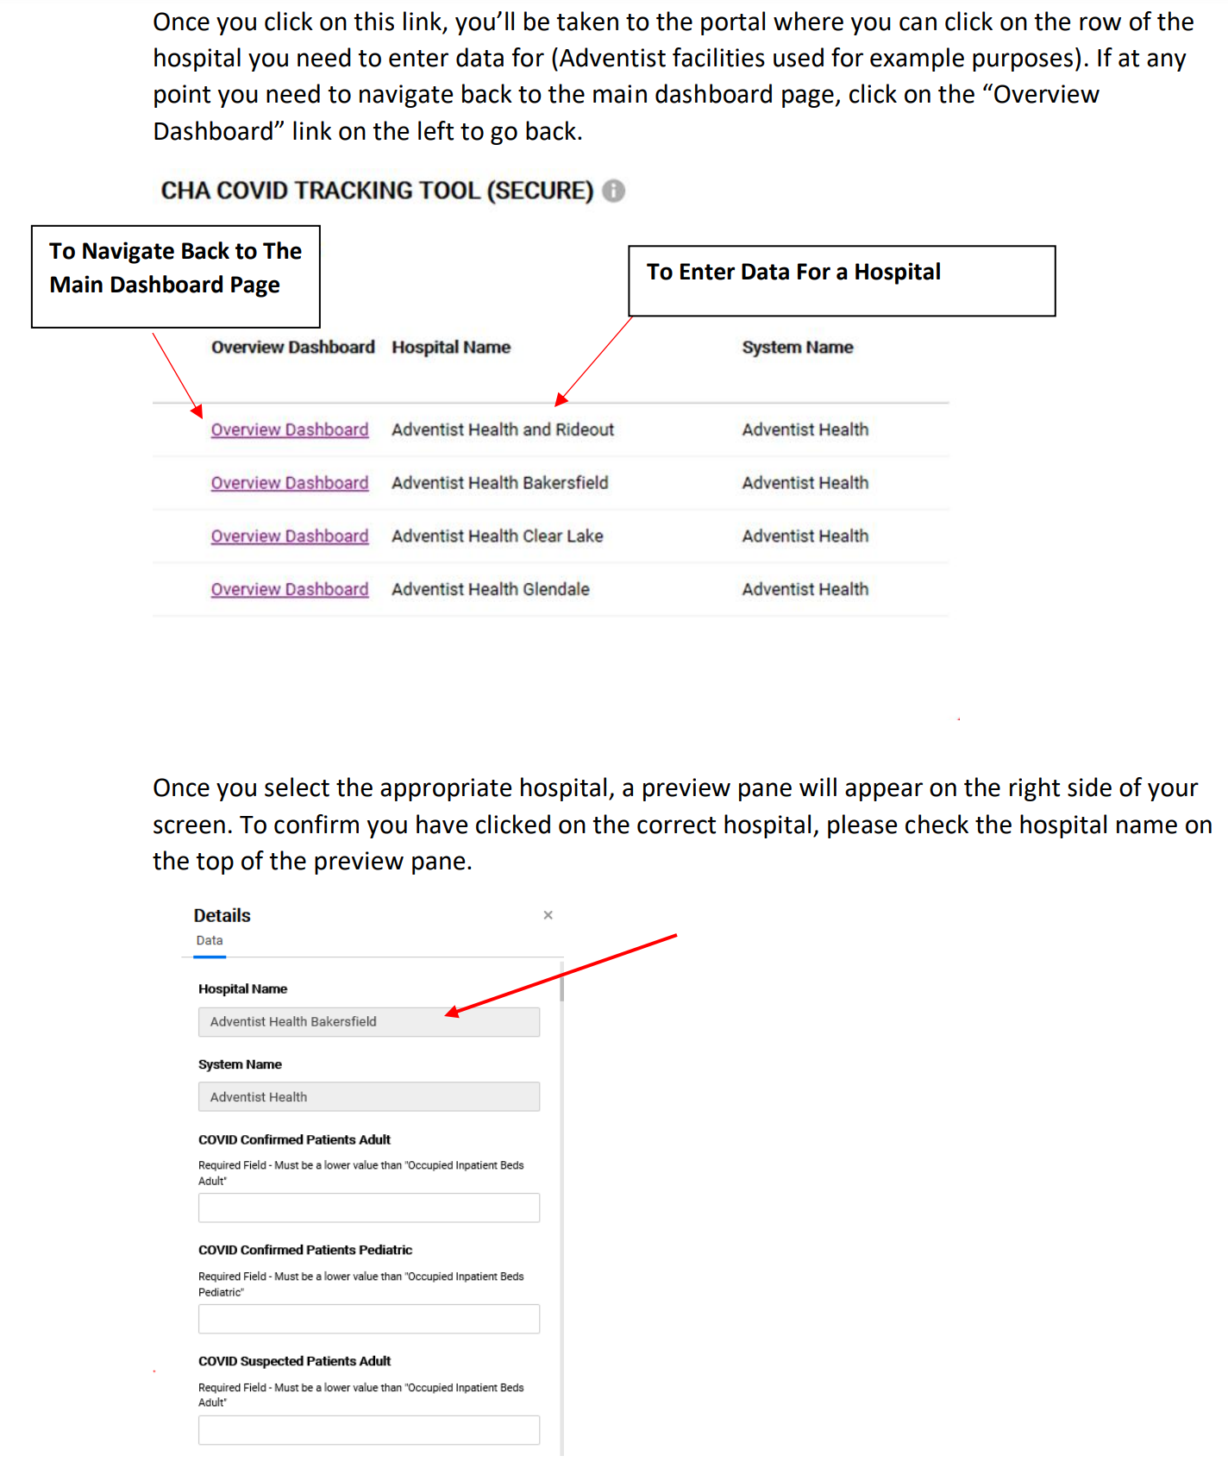
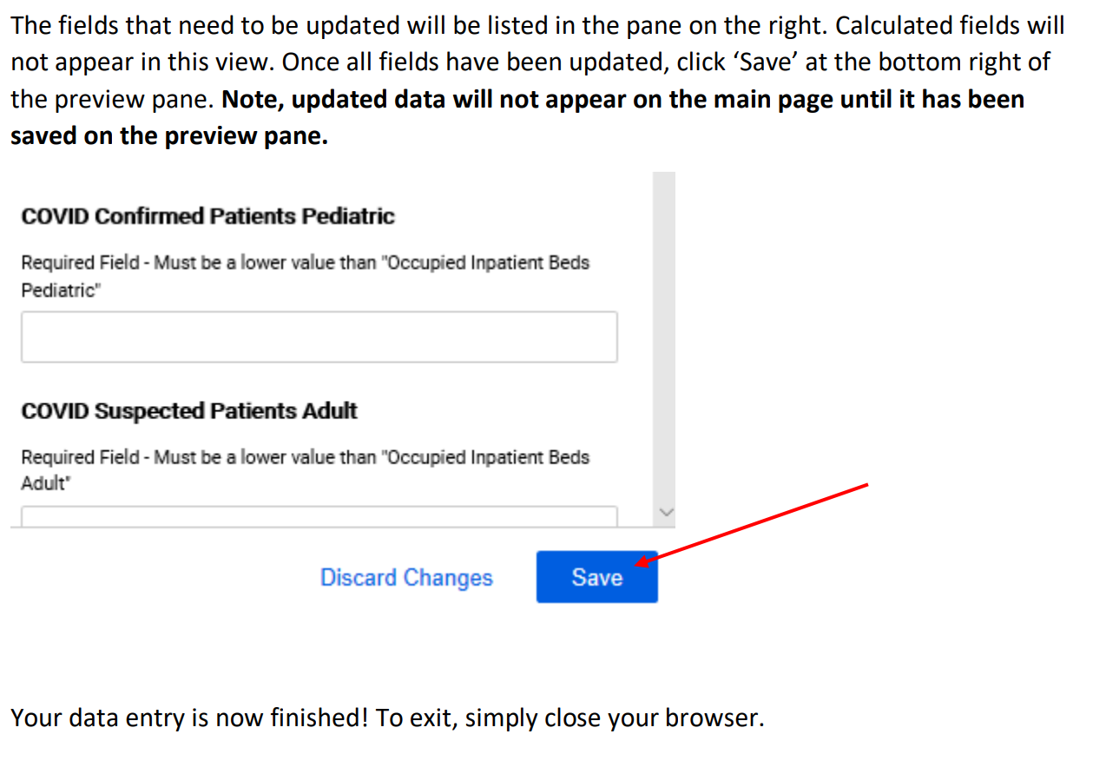

Instructions for Data Uploading via Excel Spreadsheet
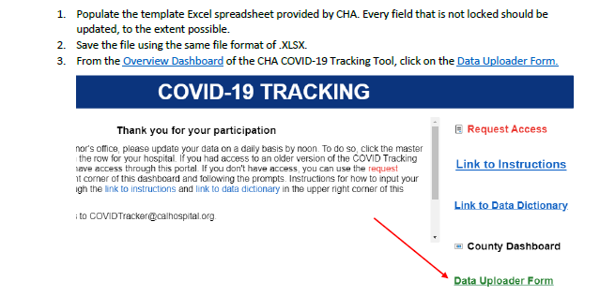
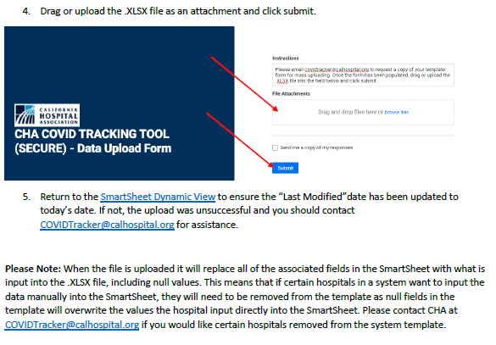

When Data Won’t Upload Using the Data Upload Function
If the “Last Modified” date doesn’t reflect today’s date, this means the data upload was not successfully completed. This is typically caused by one of two reasons:
  - When multiple hospitals attempt to upload the Excel template at the same time, the SmartSheet platform will not allow the files to go through simultaneously; it can only accept one file at a time. The user should wait a couple of minutes and try again.
  - If the above does not work, check the format of the data in the Excel upload template. The data must be in a very specific format for the upload to be successful. For example, the upload will be rejected if a letter is input where a number is required or vice-versa.

Entering Data into the HHS TeleTracking Portal
Instructions on how to enter data directly into the HHS TeleTracking portal can be found on the TeleTracking website. Users can submit data for the current day or the last four days using the data upload feature. Any questions or issues with reporting should be directed to TeleTracking Support or by calling TeleTracking at 877-570-6903, press 7.

Additional Guidance for General Reporting
Additional guidance that may aid in the reporting process includes:
- Blank Cells:
If there is a variable with a value of zero, it is very important to input zero and not leave the field blank. If the hospital doesn’t have a specific unit (e.g., emergency department, adult beds, intensive care unit), enter a zero for the related field but do not leave it blank. The exception is for fields that are only required to be reported on Wednesday (e.g., personal protective equipment). These fields may be left blank on the other six days of the week or the value from the previous Wednesday can be caried over until the next Wednesday.
- Correcting Erroneous Data Submissions from a Prior Day:
Hospitals that need to correct erroneous data from a prior day’s submission should do two things:
  - Email the corrections to CDPH at COVID-19-CHCQData@cdph.ca.gov, notifying them of the erroneous submission and the correction.
  - Correct the data in TeleTracking. For corrections prior to the last seven days, contact TeleTracking support at hhs-protect@teletracking.com or 877-570-6903, press 7.

- Retroactive Reporting (reporting the weekend’s data on a Monday):
For state reporting, hospitals need to report data every day. The CHA COVID-19 Tracking Tool utilizes the SmartSheet platform, which is unable to process retroactive reporting.
For federal reporting, the HHS TeleTracking portal will accept data retroactively. Hospitals should report missed days' data by entering the data directly into the TeleTracking portal. NOTE: This does not change the state requirement to report to the CHA COVID-19 Tracking Tool daily. Hospitals that have opted out of the state reporting to HHS will still be required to submit daily data to the CHA COVID-19 Tracking Tool even if they are retroactively reporting to HHS.
- Common Input Errors:
  - Do not input any text or special characters (e.g., N/A, Unknown, 13-NICU) into numeric fields.
  - Do not input decimals into whole number fields (e.g., 6376.00000, 168.3)
  - Do not combine multiple days’ data.
  - Do not add leading or trailing zeros (e.g., 000555, 7876830000000)
Appendix

Data Dictionary – Additional Clarifications
Variable | Data Dictionary Definition | Additional Clarification
COVID Confirmed Patients | The number of observation patients and inpatients in the hospital who have laboratory- confirmed COVID-19. Once a patient has laboratory-confirmed COVID-19, the patient should be included in this field until discharge. | A positive test does not need to be confirmed by the CDC for the patient to be categorized as a COVID-19 confirmed case.  Include patients co-infected with COVID-19 and influenza.
COVID Confirmed Patients Adult | The number of observation patients and inpatients in adult beds in the hospital who have laboratory-confirmed COVID-19. Once a patient has laboratory-confirmed COVID-19, the patient should be included in this field until discharge. | A positive test does not need to be confirmed by the CDC for the patient to be categorized as a COVID-19 confirmed case.  Include patients co-infected with COVID-19 and influenza.
COVID Confirmed Patients Pediatric | The number of observation patients and inpatients in pediatric beds (including NICU) in the hospital who have laboratory- confirmed COVID-19. Once a patient has laboratory-confirmed COVID-19, the patient should be included in this field until discharge. | A positive test does not need to be confirmed by the CDC for the patient to be categorized as a COVID-19 confirmed case.  Include patients co-infected with COVID-19 and influenza.
Total Ventilators in Hospital in Use Any Dx | The total number of mechanical ventilators in use for patients with any diagnosis at the time the data are collected, including adult, pediatric, neonatal ventilators, anesthesia machines and portable/transport ventilators. Include BiPAP machines if the hospital uses BiPAP to deliver positive pressure ventilation via artificial airways. | This number is meant to represent the total number of ventilators in your hospital of any type and matches the definition provided in the HHS guidance.
Total Non-Surge Beds | The total number of all staffed inpatient and outpatient beds in your hospital used for inpatients (includes ICU) and outpatients (includes observation beds). If the bed is not currently staffed or equipped but is usable and has the potential to be staffed and equipped using routine available hospital resources and staffing, it should be counted. This number should exclude surge beds. | Psychiatric, maternity, and L&D beds should be included.
Total Non-Surge Beds Adult | The total number of all staffed adult (as defined by room designation) inpatient (includes ICU) and outpatient (includes observation) beds in your hospital. If the bed is not currently staffed or equipped but is usable and has the potential to be staffed and equipped using routine available hospital resources and staffing, it should be counted. This number should exclude surge beds. | Psychiatric, maternity, and L&D beds should be included.
Occupied Non-Surge Inpatient Beds | The number of beds currently occupied with patients. This includes any patients who may be located in an outpatient area within the facility (e.g., ED or PACU bays) who have an inpatient or observation order. This number should exclude occupied surge beds. | Psychiatric, maternity, and L&D beds should be included.
Occupied Non-Surge Inpatient Beds Adult | The number of adult beds occupied with a patient. This includes any patients who may be located in an outpatient area within the facility (e.g., ED or PACU bays) who have an inpatient or observation order. This number should exclude occupied surge beds. | Psychiatric, maternity, and L&D beds should be included.
Total Non-Surge Inpatient Beds | The total number of all staffed inpatient beds in your hospital (including all ICU beds). If the bed is not currently staffed or equipped but is usable and has the potential to be staffed and equipped using routine available hospital resources and staffing, it should be counted. This number should also include outpatient beds that are holding inpatients who are boarding and should exclude surge beds. | Psychiatric, maternity, and L&D beds should be included.
Total Non-Surge Inpatient Beds Adult | The total number of all staffed inpatient adult beds in your hospital (including all ICU beds). If the bed is not currently staffed or equipped but is usable and has the potential to be staffed and equipped using routine available hospital resources and staffing, it should be counted. This number should also include outpatient beds that are holding inpatients who are boarding and should exclude surge beds. | Psychiatric, maternity, and L&D beds should be included.
Surge Beds | The number of additional inpatient beds that the hospital could add if all available space were used for patient care, a process allowed under the terms of the temporary Department of Public Health waiver. This number should include all beds in spaces not routinely used for patient care (e.g., gift shop, outdoor tents, hallways, etc.). If the bed is not currently staffed and equipped but is usable and has the potential to be staffed and equipped under the hospital's established surge plan, it should be counted. | Surge beds are all beds above the usual hospital capacity that can be equipped and staffed within approximately 72 hours and all other non-licensed beds.
Surge Bed Non-ICU Patients | The number of patients occupying non-ICU surge beds at the hospital. | Surge beds are all beds above the usual hospital capacity that can be equipped and staffed within approximately 72 hours and all other non-licensed beds.
Surge Bed ICU Patients | The number of patients occupying ICU surge beds at the hospital. | Surge beds are all beds above the usual hospital capacity that can be equipped and staffed within approximately 72 hours and all other non-licensed beds.
Surge Bed Occupancy Rate | The percent of available surge beds in use. | Surge beds are all beds above the usual hospital capacity that can be equipped and staffed within approximately 72 hours and all other non-licensed beds.
ICU Non-Surge Occupied Beds PICU | The current number of pediatric ICU beds occupied by a patient, excluding surge beds and NICU. | Variable has been renamed from “ICU Non-Surge Occupied Beds Pediatric.”
ICU Non-Surge Occupied Beds NICU | The current number of neonatal ICU beds occupied by a patient, excluding surge beds. | This variable has been newly added.
ICU Non-Surge Total Beds PICU | The current number of physical, staffed inpatient pediatric intensive care beds in the facility. If the intensive care bed is not currently staffed and equipped but is usable and has the potential to be staffed and equipped using routine available hospital resources and staffing, using available hospital resources and staffing, it should be counted. The same would apply to a blocked intensive care bed. If the intensive care bed is currently blocked, but is a usable bed, it should be counted. This number should exclude surge beds and NICU. | Variable has been renamed from “ICU Non-Surge Total Beds Pediatric.”
ICU Non-Surge Total Beds NICU | The current number of physical, staffed inpatient neonatal intensive care beds in the facility. If the intensive care bed is not currently staffed and equipped but is usable and has the potential to be staffed and equipped using routine available hospital resources and staffing, using available hospital resources and staffing, it should be counted. The same would apply to a blocked intensive care bed. If the intensive care bed is currently blocked, but is a usable bed, it should be counted. This number should exclude surge beds. | This variable has been newly added.
Admits in Previous Day Confirmed | The total number of patients who were admitted to an inpatient bed on the previous calendar day (12 a.m. - 11:59 p.m.) and who had confirmed COVID-19 at the time of admission. | This variable is not the same as the previous day’s census.
Admits in Previous Day Suspected | The total number of patients who were admitted to an inpatient bed on the previous calendar day (12 a.m. - 11:59 p.m.) and who had suspected COVID-19 at the time of admission. | This variable is not the same as the previous day’s census.
Admits in Previous Day Confirmed vs. Suspected | Confirmed - The total number of patients who were admitted to an inpatient bed on the previous calendar day (12 a.m. - 11:59 p.m.) and who had confirmed COVID-19 at the time of admission.  Suspected - The total number of patients who were admitted to an inpatient bed on the previous calendar day (12 a.m. - 11:59 p.m.) and who had suspected COVID-19 at the time of admission. | The data fields are seeking to capture the status of those admitted the previous day at the time of admission. So, if someone was admitted at 1 p.m. and you knew the patient was COVID-19 positive, then this would be in the previous day's confirmed counts. If the patient was symptomatic at 1 p.m. but you did not yet have a positive test in hand (or a result coming in the very near future from a rapid test), then this patient would be included in the previous day's suspected counts (even if you learn later in the day that the patient was COVID-19 positive). If a patient was admitted for non-COVID-19 reasons, but you learn later they are positive, then this patient would not be included.
Ventilator Supplies Days On Hand | The calculated days of supply in stock for ventilator supplies. Calculation may be provided by your hospital's ERP system or by utilizing the CDC's PPE burn rate calculator assumptions. For supply categories such as this that may have varying quantities, days on hand, or ability to obtain and maintain, reply for the item that has the lowest stock on hand. | Base response on the item that has the lowest stock on hand. If an item has multiple parts, a shortage of one part indicates a shortage of that item.  Only consider ventilator supplies  that the hospital is able to maintain using internal resources.
Ventilator Supplies Able to Obtain | Select "Yes" if your facility is able to order and obtain ventilator supplies. Select "No" if your facility is not able to order and obtain ventilator supplies. | Base response on the item that has the lowest stock on hand. If an item has multiple parts, a shortage of one part indicates a shortage of that item.  Only consider ventilator supplies that the hospital is able to maintain using internal resources.
Ventilator Supplies: Can Maintain 3-Day Supply? | Select "Yes" if you are able to maintain at least a 3-day supply for ventilator supplies. Select "No" if you are not able to maintain at least a 3-day supply for ventilator supplies. | Base response on the item that has the lowest stock on hand. If an item has multiple parts, a shortage of one part indicates a shortage of that item.  Only consider ventilator supplies  that the hospital is able to maintain using internal resources.
Ventilator Medications Able to Obtain | Select "Yes" if your facility is able to order and obtain ventilator medications. Select "No" if your facility is not able to order and obtain ventilator medications. Ventilator medications include Propofol, Midazolam, Dexmedetomidine, Hydromorphone, Fentanyl, Cisatracurium, and Rocuronium. | Base response on the item that has the lowest stock on hand. If an item has multiple parts, a shortage of one part indicates a shortage of that item.
Ventilator Medications: Can Maintain 3-Day Supply? | Select "Yes" if you are able to maintain at least a 3-day supply for ventilator medications. Select "No" if you are not able to maintain at least a 3-day supply for ventilator medications. Ventilator medications include Propofol, Midazolam, Dexmedetomidine, Hydromorphone, Fentanyl, Cisatracurium, and Rocuronium. | Base response on the item that has the lowest stock on hand. If an item has multiple parts, a shortage of one part indicates a shortage of that item.
Total N95 Masks | The current number of N95 masks ready for use. This field is optional and should be provided only if feasible. | Report this variable once a week on Wednesday and only if it is feasible.
Total Surgical and Procedure Masks | The current number of surgical and procedure masks ready for use. This field is optional and should be provided only if feasible. | Report this variable once a week on Wednesday and only if it is feasible.  Base response on the item that has the lowest stock on hand. If an item has multiple parts, a shortage of one part indicates a shortage of that item.
Surgical and Procedure Mask Days On Hand | The calculated days of supply in stock for surgical and procedure masks. Calculation may be provided by your hospital's ERP system or by utilizing the CDC's PPE burn rate calculator assumptions. For supply categories such as this that may have varying quantities, days on hand, or ability to obtain and maintain, reply for the item that has the lowest stock on hand. | Base response on the item that has the lowest stock on hand. If an item has multiple parts, a shortage of one part indicates a shortage of that item.
Surgical and Procedure Masks Able to Obtain | Select "Yes" if your facility is able to order and obtain surgical and procedure masks. Select "No" if your facility is not able to order and obtain surgical and procedure masks. | Base response on the item that has the lowest stock on hand. If an item has multiple parts, a shortage of one part indicates a shortage of that item.
Surgical and Procedure Masks: Can Maintain 3-Day Supply? | Select "Yes" if you are able to maintain at least a 3-day supply for surgical and procedure masks. Select "No" if you are not able to maintain at least a 3-day supply for surgical and procedure masks. | Base response on the item that has the lowest stock on hand. If an item has multiple parts, a shortage of one part indicates a shortage of that item.
Total Eye Protection | The current number of eye protection pieces (including face shields and goggles) ready for use. For supply categories such as this that may have varying quantities, days on hand, or ability to obtain and maintain, reply for the item that has the lowest stock on hand. This field is optional and should be provided only if feasible. | Report this variable once a week on Wednesday and only if it is feasible.  Base response on the item that has the lowest stock on hand. If an item has multiple parts, a shortage of one part indicates a shortage of that item.
Eye Protection Days On Hand | The calculated days of supply in stock for eye protection pieces (including face shields and goggles). Calculation may be provided by your hospital's ERP system or by utilizing the CDC's PPE burn rate calculator assumptions. | Base response on the item that has the lowest stock on hand. If an item has multiple parts, a shortage of one part indicates a shortage of that item.
Eye Protection Able to Obtain | Select "Yes" if your facility is able to order and obtain eye protection. Select "No" if your facility is not able to order and obtain eye protection. | Base response on the item that has the lowest stock on hand. If an item has multiple parts, a shortage of one part indicates a shortage of that item.
Eye Protection: Can Maintain 3-Day Supply? | Select "Yes" if you are able to maintain at least a 3-day supply for eye protection pieces (including face shields and goggles). Select "No" if you are not able to maintain at least a 3-day supply for eye protection. | Base response on the item that has the lowest stock on hand. If an item has multiple parts, a shortage of one part indicates a shortage of that item.
Total Exam Gloves | The current number of exam gloves ready for use. This field is optional and should be provided only if feasible. | Report this variable once a week on Wednesday and only if it is feasible.
Total Single Use Gowns | The current number of single use gowns ready for use. This field is optional and should be provided only if feasible. | Report this variable once a week on Wednesday and only if it is feasible.
Total PAPR | The current number of PAPR ready for use. This field is optional and should be provided only if feasible. | Report this variable once a week on Wednesday and only if it is feasible.
PAPR Reusing/Extended Use | Enter YES if your facility re-uses or extends the use of this supply. Enter NO if your facility does not re-use or extend the use of this supply. Enter N/A if the item is not applicable for your facility. | Base response on the item that has the lowest stock on hand. If an item has multiple parts, a shortage of one part indicates a shortage of that item.
PAPR Able to Obtain | Select "Yes" if your facility is able to order and obtain PAPR. Select "No" if your facility is not able to order and obtain PAPR. | Base response on the item that has the lowest stock on hand. If an item has multiple parts, a shortage of one part indicates a shortage of that item.
PAPR: Can Maintain 3-Day Supply? | Select "Yes" if you are able to maintain at least a 3-day supply for PAPR. Select "No" if you are not able to maintain at least a 3-day supply for PAPR. | Base response on the item that has the lowest stock on hand. If an item has multiple parts, a shortage of one part indicates a shortage of that item.
Total Launderable Gowns | The current number of launderable gowns ready for use. | Report this variable once a week on Wednesday and only if it is feasible.
Supply or Medication Shortages | Using free text, indicate any specific or critical medical supplies or medication shortages you are currently experiencing or anticipate experiencing in the next three days. | This variable has been newly added.
Total Hospitalized Influenza | The number of patients of any age currently hospitalized in an inpatient bed who have laboratory-confirmed influenza. Include those in observation beds. | This variable has been newly added.  Include patients co-infected with COVID-19 and influenza.
Admits in Previous Day Influenza | The number of patients of any age who were admitted to an inpatient bed on the previous calendar day who had laboratory-confirmed influenza at the time of admission. Include those in observation beds. | This variable has been newly added.  Include patients co-infected with COVID-19 and influenza.
Total ICU Influenza | The number of patients of any age currently hospitalized in the ICU (of any type) with laboratory-confirmed influenza. Include those in observation beds. | This variable has been newly added.  Include patients co-infected with COVID-19 and influenza.
Total Hospitalized Influenza AND COVID | The number of patients of any age currently hospitalized in an inpatient bed who have laboratory-confirmed COVID-19 and laboratory-confirmed influenza. Include those in observation beds. | This variable has been newly added.
Previous Day’s Influenza Deaths | The number of patients with laboratory-confirmed influenza who died on the previous calendar day in the hospital, ED, or any overflow location. | This variable has been newly added.  Include patients co-infected with COVID-19 and influenza.
Previous Day’s Influenza AND COVID Deaths | The number of patients with laboratory-confirmed influenza AND laboratory-confirmed COVID-19 who died on the previous calendar day in the hospital, ED, or any overflow location. | This variable has been newly added.

CMS Enforcement Process for Non-Compliance
CMS has established a multi-step approach to enforcement of non-compliance with the hospital reporting requirements implemented in the September 2, 2020 interim final rule. Hospitals that fail to report the specified data elements will receive a notification from CMS. Any further noncompliance with CMS’ reporting requirements may result in the following enforcement actions.
- Hospitals that do not meet the reporting requirements completely will receive an initial notification from CMS. This notification of non-compliance will also serve as a reminder of the reporting requirements.
- Three weeks after receiving an initial notification of noncompliance with reporting requirements, hospitals that continue not to submit the specified information daily and completely will receive a second reminder notification of their failure to meet the reporting requirements and that future enforcement actions will be taken for continued noncompliance, which may result in termination of the Medicare provider agreement.
- Hospitals that have continually failed to meet the reporting requirements for a period of six weeks after receiving an initial notification will receive the first in a series of enforcement notification letters. At this point, the enforcement actions are now in process, and hospitals will have one calendar week to demonstrate compliance.
- Hospitals failing to meet the reporting requirements within one calendar week following the first enforcement notification letter will receive a second enforcement notification letter. This notification will indicate that that the hospital will have one calendar week to demonstrate compliance with the reporting requirements; otherwise, the hospital will receive the third and final enforcement notification letter, as noted in step 5.
- Hospitals that have failed to meet the reporting requirements within one week following the second enforcement notification letter will receive a third and final enforcement notification letter. This notification will include a notice of termination to become effective within 30 days from the date of the notification. Failure to meet the reporting requirements within this 30-day time frame may result in termination of the Medicare hospital agreement.

CDPH Calculations Prior to Uploading Data to TeleTracking
Hospitals that have opted in for the state to report data to HHS via the TeleTracking portal on their behalf may notice that the CHA COVID-19 Tracking Tool variables are different than those in TeleTracking. CDPH has bifurcated some of the HHS variables and uses specific calculations to align with the HHS definitions. The table below shows the list of HHS variables that are calculated by CDPH prior to submission.

HHS Variable | HHS Variable Definition | CDPH Calculation
All hospital beds | Total number of all staffed inpatient and outpatient beds in your hospital, including all overflow, observation, and active surge/expansion beds used for inpatients and for outpatients (includes all ICU, ED, and observation). | Total Non-Surge Beds + Surge Bed Non-ICU Patients + Surge Bed ICU Patients
All adult hospital beds | Total number of all staffed inpatient and outpatient adult beds in your hospital, including all overflow, observation, and active surge/expansion beds used for inpatients and for outpatients (includes all ICU, ED, and observation). | Total Non-Surge Beds + Surge Bed Non-ICU Patients + Surge Bed ICU Patients
All hospital inpatient beds | Total number of staffed inpatient beds in your hospital including all overflow, observation, and active surge/expansion beds used for inpatients (includes all ICU beds). | Total Non-Surge Inpatient Beds + Surge Bed Non-ICU Patients + Surge Bed ICU Patients
Adult hospital inpatient beds | Total number of staffed inpatient adult beds in your hospital including all overflow and active surge/expansion beds used for inpatients (includes all designated ICU beds). | Total Non-Surge Inpatients Beds Adult + Surge Bed Non-ICU Patients + Surge Bed ICU Patients
All hospital inpatient bed occupancy | Total number of staffed inpatient beds that are occupied. | Occupied Non-Surge Inpatient Beds + Surge Bed Non-ICU Patients + Surge Bed ICU Patients
Adult hospital inpatient bed occupancy | Total number of staffed inpatient adult beds that are occupied. | Occupied Non-Surge Inpatient Beds Adult + Surge Bed Non-ICU Patients + Surge Bed ICU Patients
ICU beds | Total number of staffed inpatient ICU beds. | ICU Non-Surge Total Beds + Surge Bed ICU Patients
Adult ICU beds | Total number of staffed inpatient adult ICU beds. | ICU Non-Surge Total Beds Adult + Surge Bed ICU Patients
ICU bed occupancy | Total number of staffed inpatient ICU beds that are occupied. | ICU Non-Surge Occupied Beds + Surge Bed ICU Patients
Adult ICU bed occupancy | Total number of staffed inpatient adult ICU beds that are occupied. | ICU Non-Surge Occupied Beds Adult + Surge Bed ICU Patients
Total hospitalized adult suspected or confirmed positive COVID patients | Patients currently hospitalized in an adult inpatient bed who have laboratory-confirmed or suspected COVID-19. Include those in observation beds. Once a patient has laboratory confirmed COVID-19, the patient should be included in the appropriate COVID confirmed field until discharge. | COVID-Confirmed Patients Adult + COVID-Suspected Patients Adult
Total hospitalized pediatric suspected or confirmed positive COVID patients | Patients currently hospitalized in a pediatric inpatient bed who have laboratory-confirmed or suspected COVID-19. Include those in observation beds. Once a patient has laboratory confirmed COVID-19, the patient should be included in the appropriate COVID confirmed field until discharge. | COVID-Confirmed Patients Pediatric + COVID-Suspected Patients Pediatric
Total ICU adult suspected or confirmed positive COVID patients | Patients currently hospitalized in a designated adult ICU bed who have suspected or laboratory-confirmed COVID-19. | ICU Confirmed Patients Adult + ICU Suspected Patients Adult
ED/overflow | Patients with suspected or laboratory-confirmed COVID-19 who currently are in the Emergency Department (ED) or any overflow location awaiting an inpatient bed. | ED and Overflow Confirmed Patients + ED and Overflow Suspected Patients Adult
ED/overflow and ventilated | Patients with suspected or laboratory-confirmed COVID-19 who currently are in the ED or any overflow location awaiting an inpatient bed and on a mechanical ventilator. | COVID ED and Overflow Patients Using Ventilation Adult + COVID ED and Overflow Patients Using Ventilation Pediatric
Previous day’s adult admissions with confirmed COVID-19 and breakdown by age bracket | Enter the number of patients who were admitted to an adult inpatient bed on the previous calendar day who had confirmed COVID-19 at the time of admission. As a subset, provide the breakdown by age bracket:  18-19  20-29  30-39  40-49  50-59  60-69  70-79  80+  Unknown | Admits in Previous Day Confirmed by Age (excluding the 0-17 age group)
Previous day’s adult admissions with subset COVID-19 and breakdown by age bracket | Enter the number of patients who were admitted to an adult inpatient bed on the previous calendar day who had confirmed COVID-19 at the time of admission. As a subset, provide the breakdown by age bracket:  18-19  20-29  30-39  40-49  50-59  60-69  70-79  80+  Unknown | Admits in Previous Day Suspected by Age (excluding the 0-17 age group)
Previous day’s pediatric admissions with confirmed COVID-19 | Enter the number of pediatric patients who were admitted to an inpatient bed, including NICU, PICU, newborn, and nursery, on the previous calendar day who had confirmed COVID-19 at the time of admission. | Admits in Previous Day Confirmed by Age (only the 0-17 age group)
Previous day’s pediatric admissions with suspected COVID-19 | Enter the number of pediatric patients who were admitted to an inpatient bed, including NICU, PICU, newborn, and nursery, on the previous calendar day suspected of having COVID-19 at the time of admission. | Admits in Previous Day Suspected by Age (only the 0-17 age group)

Other Resources
CDPH AFL
CPDH’s All Facilities Letter 20-31.2 outlines the data reporting requirements for hospitals and informs hospitals that CDPH will submit data on their behalf via the HHS TeleTracking portal.

TeleTracking Data Dictionary and Validation Rules
The TeleTracking data dictionary provides definitions of the variables required by HHS. This also includes the validation rules applied by TeleTracking to ensure the integrity of the data.

HHS Guidance
This guidance provides the required data reporting and frequently asked questions.

CMS Interim Final Rule on COVID-19 Reporting
The interim final rule includes CMS’ authority to enforce COVID-19 reporting compliance as a Medicare condition of participation.

CHA COVID-19 Tracking Tool Data Dictionary on CHA Website
The current CHA COVID-19 Tracking Tool data dictionary defines the variables that are required to be reported.

TeleTracking Release Notes
The TeleTracking release notes outline the updates to data reporting requirements for HHS TeleTracking.

TeleTracking Video Tutorial Gallery
These tutorial videos explain how to use the TeleTracking website.

